**Pracovní list A – výsledky**

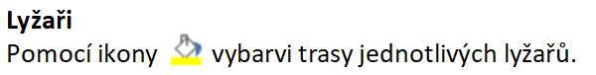

|  |  |  |  |  |  |  |  |  |  |  |
| --- | --- | --- | --- | --- | --- | --- | --- | --- | --- | --- |
|  | → | → | → | ↓ | ↓ | ↓ | ← | ← | ← | ↓ |
|  | ↑ | ↑ | ↑ | ← | ← | ← | ↑ | ↑ | ↑ | → |
|  | → | → | ↓ | ↓ | ↓ | → | → | → | ↑ | ↑ |

|  |  |  |  |  |  |  |  |  |  |
| --- | --- | --- | --- | --- | --- | --- | --- | --- | --- |
|  |  |  |  |  |  |  |  |  |  |
|  |  | |  |  | |  |  | |  |
|  |  |  |  |
|  |  |  |  |  |  |  |  |  |  |
|  |  | |  | Lyžařský  areál | |  |  | |  |
|  |  |  |  |
|  |  |  |  |  |  |  |  |  |  |
|  |  | |  |  | |  |  | |  |
|  |  |  |  |
|  |  |  |  |  |  |  |  |  |  |