ZÁBAVNÁ MATEMATIKA II. – SPRÁVNÉ ŘEŠENÍ

Vypočítej příklad a písmenko zapiš do tabulky:
Na jaře kvetou
5 | 13 | 8 | 9 | 15 | 10 | 11 | 12 | 5 | 10 | 27
S | E | D | M | I | K | R | Á | S | K | Y

Á = 10 + (18 : 9) 12 M = 72 : (2 . 4) 9
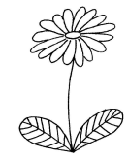
E = (6 . 4) − 9 13 I = (2 . 10) − 5 15
R = 23 − (6 . 2) 11 D = (44 − 4) : 5 8
K = (49 : 7) + 3 10 S = (5 . 2) − 5 5
S = (27 : 9) + 2 5 K = 40 − (5 . 6) 10
Y = (21 : 7) . 9 27
Tajenka:
-------------------------------------------------------------------------------------------------------------------------
32 | 60 | 87 | 100 | 58 | 60 | 33 | 21
S | N | Ě | Ž | E | N | K | Y

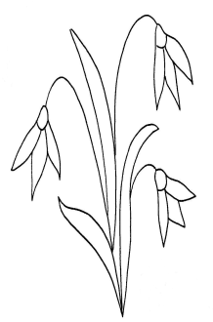
N = (8 . 9) − 12 60 S = (7 . 6) − 10 32
Ě = (8 . 8) + 23 87 Ž = (6 . 8) + 52 100
Y = 39 − (3 . 6) 21 E = 64 − (36 : 6) 58
K = 24 + (72 : 8) 33 N = (9 . 10) − 30 60
Tajenka:
………………………………………………………………………………………………………………
45 | 9 | 36 | 43 | 3 | 18 | 16 | 12
T | U | L | I | P | Á | N | Y

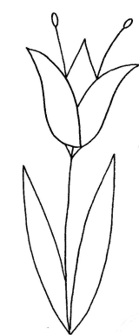
T = (6 . 3) + 27 45 U = 45 − (6 . 6) 9
I = 63 − (2 . 10) 43 L = (2 . 9) + 18 36
Á = 12 + (48 : 8) 18 P = 33 − (6 . 5) 3
Y = 24 − (4 . 3) 12 N = (56 : 7) + 8 16

Tajenka:
………………………………………………………………………………………………………………………………………

12 | 40 | 47 | 4 | 30 | 1 | 29 | 38
N | A | R | C | I | S | K | Y

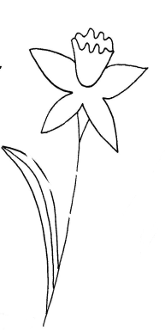
A = (48 : 8) + 34 40 R = 56 − (81 : 9) 47
N= 28 − (4 . 4) 12 I = (8 . 8) − 34 30
S = 26 − (5 . 5) 1 C = (12 : 6) + 2 4
Y = 80 − (6 . 7) 38 K = 50 − (7 . 3) 29

Tajenka:
………………………………………………………………………………………………………………………………………
10 | 20 | 30 | 40 | 30 | 10 | 50
K | O | Č | I | Č | K | Y
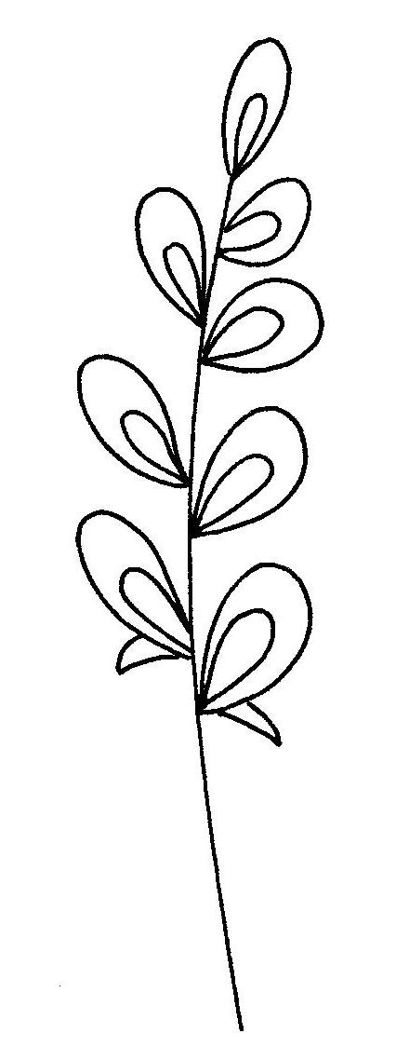
O = 10 + (2 . 5) 20 K = 100 − (9 . 10) 10
Č = 0 + (3 . 10) 30 I = 32 + (72 : 9) 40
Č = (42 : 7) . 5 30 Y = 25 + (5 . 5) 50
K = (3 . 3) + 1 10

Tajenka:
………………………………………………………………………………………………………………………………………

10 | 11 | 12 | 13 | 14 | 15
F | I | A | L | K | Y

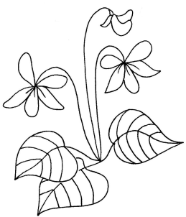

I = 74 − (7 . 9) 11 A = (6 . 2) + 0 12
F = (15 : 3) + 5 10 L = 3 + (80 : 8) 13
K = 95 − (9 . 9) 14 Y = (5 . 9) − 30 15

Tajenka:
………………………………………………………………………………………………………………………………………

