THE CATS

Look, what are the cats doing. Write:

- How many cats are sleeping? ____
- How many cats are drinking? ____
- How many cats are yawning? ____
- How many cats are standing? ____
- How many cats are sitting? ____

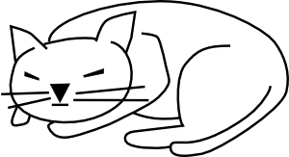
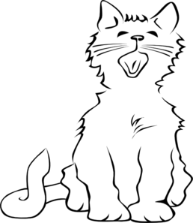
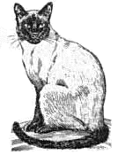
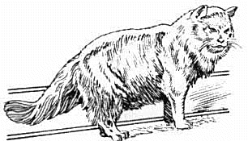
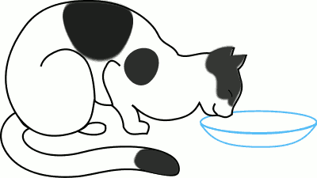

THE DOGS

Look, what are the dogs doing. Write:

- How many dogs are running? ____
- How many dogs are going? ____
- How many dogs are lying? ____
- How many dogs are standing? ____
- How many dogs are sitting? ____

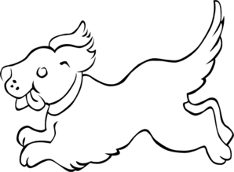
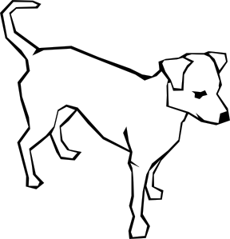
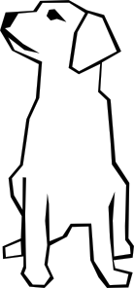
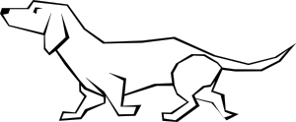
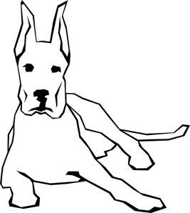

A) Count and write:

1.How many cats are in the paper? _____

2. How many dogs are in the paper? _____

3. Are there more cats or dogs in this list? _____

B) Answer the questions:

1.Have you got a dog? _______________

2. Have you got a cat? _______________

3. Do you like dogs? _______________

4. Do you like cats? _______________

5. Has your friend got a dog? _______________

6. Has your friend got a cat? _______________

Všechny uveřejněné odkazy [cit. 2012-02-26]. Dostupné pod licencí Public domain na WWW:

<http://www.clker.com/clipart-6986.html> spící kočka
<http://www.pdclipart.org/displayimage.php?album=21&pos=44> pijící kočka
<http://www.clker.com/clipart-cat-yawning.html> zívající kočka
<http://www.pdclipart.org/displayimage.php?album=21&pos=119> sedící kočka
<http://www.pdclipart.org/displayimage.php?album=21&pos=110> stojící kočka
<http://www.clker.com/clipart-13239.html> stojící pes
<http://www.clker.com/clipart-13240.html> ležící pes
<http://www.clker.com/clipart-13248.html> sedící pes
<http://www.clker.com/clipart-13242.html> jdoucí pes
<http://www.clker.com/clipart-puppy.html> běžící pes

