FARM ANIMALS – THE BODY
LABEL THE PICTURES. CHOOSE THE WORDS FROM THE BOX.

BEAK (a bird’s mouth) | EAR (2x) | EYE
FEATHERS | HOOF (the hard part of an animal’s foot) | LEG
MANE | MOUTH | PAW (the foot of an animal)
TAIL (2x) | UDDER (the organ that produces milk) | WHISKERS

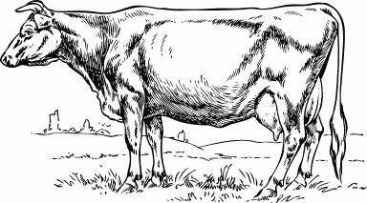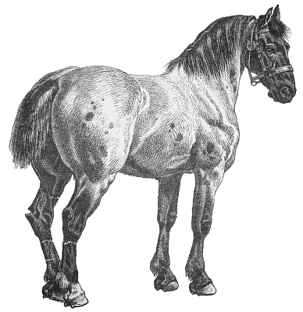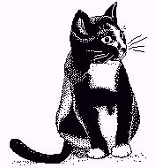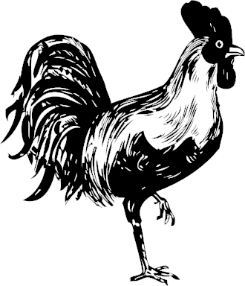
UDDER
PAW
LEG
TAIL
MOUTH
EAR
MANE
EYE
HOOF
TAIL
WHISKERS
EAR
BEAK
FEATHERS
Which animals can you see in the pictures? Write their names.

a cow, a horse, a cat, a rooster
Použité obrázky:

kráva | [cit. 2010-05-06]. Dostupné pod licencí Public Domain na WWW:  <http://www.pdclipart.org/displayimage.php?album=search&cat=0&pos=38>.
kůň | [cit. 2010-05-06]. Dostupné pod licencí Public Domain na WWW:  <http://www.pdclipart.org/displayimage.php?album=search&cat=0&pos=9>.
kočka | [cit. 2010-05-06]. Dostupné pod licencí Public Domain na WWW:  <http://www.pdclipart.org/displayimage.php?album=search&cat=0&pos=51>.
kohout | [cit. 2010-05-06]. Dostupné pod licencí Public Domain na WWW:  <http://www.pdclipart.org/displayimage.php?album=search&cat=0&pos=6>.

