Sklizeň ovoce a zeleniny

Pomůcka slouží k prohlubování znalostí ovoce a zeleniny.
Děti roztřídí druhy ovoce a zeleniny do pytlů (pomůcku je vhodné zalaminovat a jednotlivé obrázky rozstříhat).

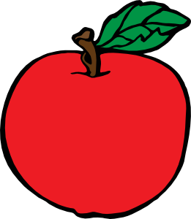
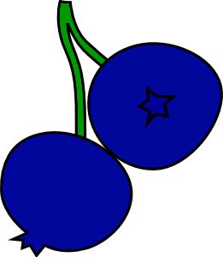
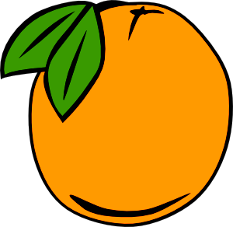

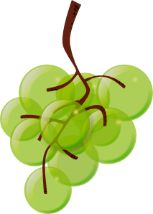
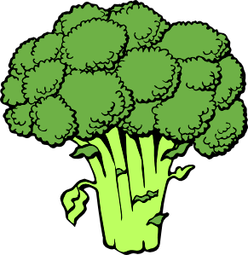
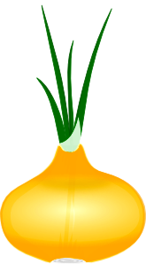

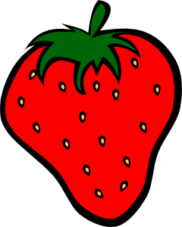
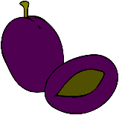

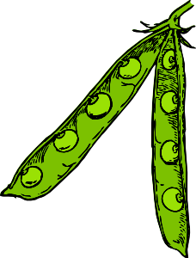
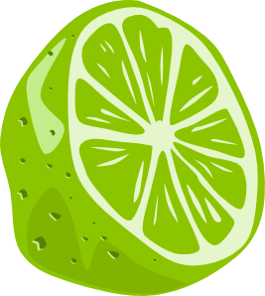
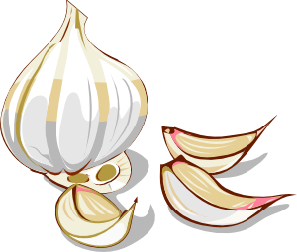
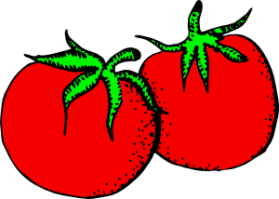

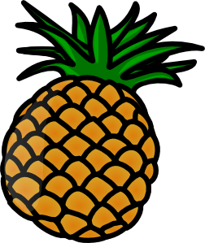

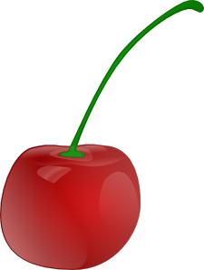
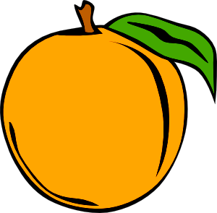

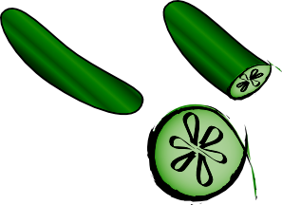
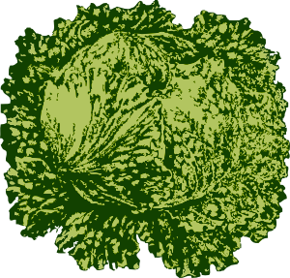

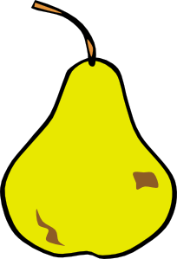
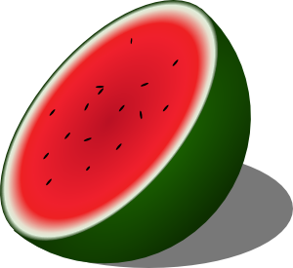

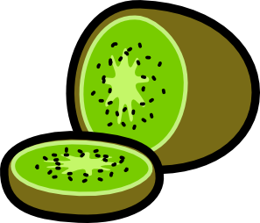






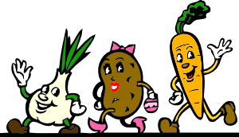

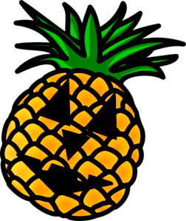

Veškerý obrazový materiál [cit. 2011-10-11]. Dostupný pod licencí Public domain na WWW:

Cartoon Eggplant ......................................................... <http://www.clker.com/clipart-cartoon-eggplant.html>
Cartoon Veggies Running ................................................................ <http://www.clker.com/clipart-9736.html>
Pineapple Jack O Lantern ................................. <http://www.clker.com/clipart-pineapple-jack-o-lantern.html>
Blueberries ..................................................................................... <http://www.clker.com/clipart-11297.html>
Orange .............................................................................................. <http://www.clker.com/clipart-4045.html>
Apple .............................................................................................. <http://www.clker.com/clipart-29025.html>
Green Grapes ...................................................................... <http://www.clker.com/clipart-green-grapes.html>
Carrots ....................................................................................... <http://www.clker.com/clipart-carrots-1.html>
Broccoli .......................................................................................... <http://www.clker.com/clipart-29024.html>
Onion ............................................................................................. <http://www.clker.com/clipart-26562.html>
Simple Fruit Ff Menu...................................................................... <http://www.clker.com/clipart-13220.html>
Steve Karg ...................................................................................... <http://www.clker.com/clipart-11106.html>
Half Lime .......................................................................................... <http://www.clker.com/clipart-4030.html>
Plum Fruit Food ............................................................................. <http://www.clker.com/clipart-10465.html>
Garlic ................................................................................................ <http://www.clker.com/clipart-4102.html>
Tomatoes ......................................................................................... <http://www.clker.com/clipart-2054.html>
Pea Pod ................................................................................... <http://www.clker.com/clipart-pea-pod-1.html>
Apple Core ....................................................................................... <http://www.clker.com/clipart-3985.html>
Fruit Orange ................................................................................... <http://www.clker.com/clipart-13218.html>
Cherry .............................................................................................. <http://www.clker.com/clipart-4061.html>
Pineaple ........................................................................................... <http://www.clker.com/clipart-3998.html>
Lettuce 2 ........................................................................................ <http://www.clker.com/clipart-13648.html>
Vegetables Set................................................................................ <http://www.clker.com/clipart-25652.html>
Fernandotre Cucumber ................................................................. <http://www.clker.com/clipart-13326.html>
Banana ............................................................................................. <http://www.clker.com/clipart-3986.html>
Kiwi And Kiwi Wedge .................................................................... <http://www.clker.com/clipart-23844.html>
Pear ................................................................................................ <http://www.clker.com/clipart-13221.html>
Watermelon...................................................................................... <http://www.clker.com/clipart-3994.html>
Lemon .............................................................................................. <http://www.clker.com/clipart-3991.html>
Vegetables Set ................................................................................ <http://www.clker.com/clipart-25651.html>
Potato ............................................................................................... <http://www.clker.com/clipart-2532.html>

