Look at the pictures and describe and compare them. What kinds of social problems do they represent? What is the prevention?

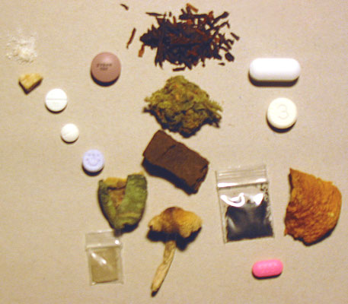

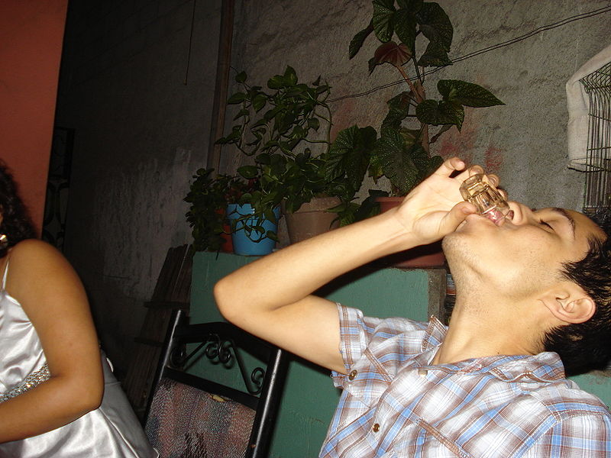
Look at the pictures and describe and compare them. What kinds of social problems do they represent? What is the prevention?

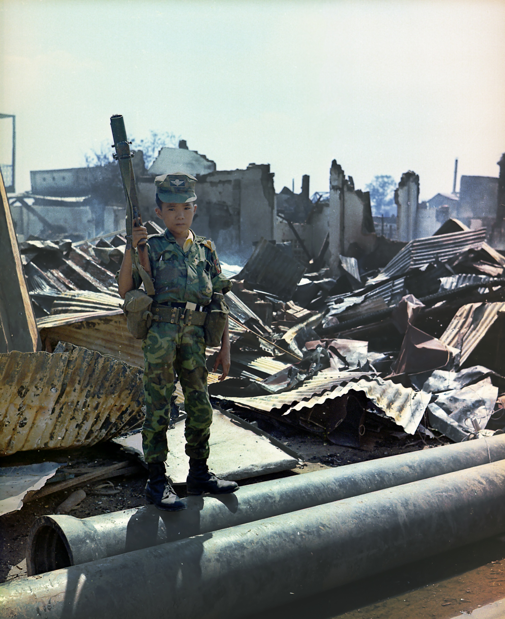

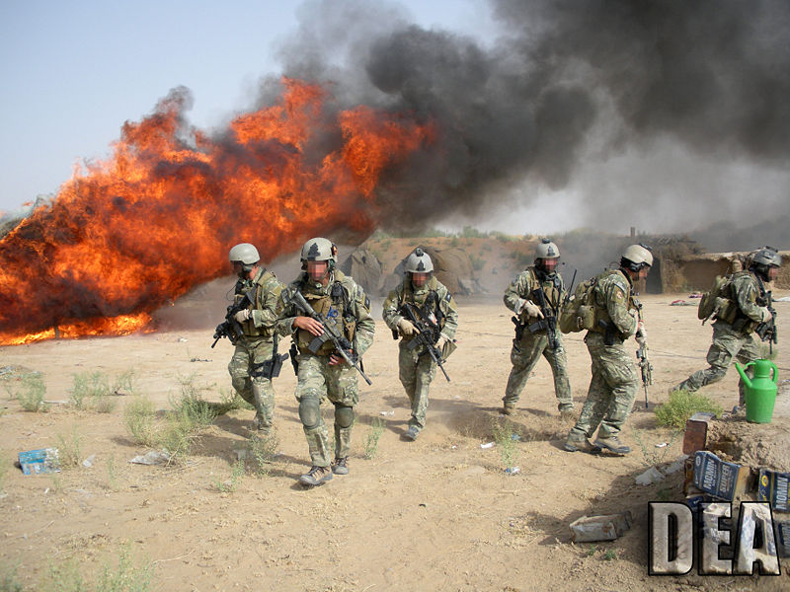

Použitý materiál:
THORIC. [cit. 2011-07-03]. Dostupný pod licencí Creative Commons na WWW:
<http://commons.wikimedia.org/wiki/File:Pyschoactive_Drugs.jpg> - drugs

Všechny uveřejněné odkazy [cit. 2011-07-03]. Dostupné pod licencí Public domain na WWW:
<http://commons.wikimedia.org/wiki/File:Caricachupas.JPG> - alcohol
<http://commons.wikimedia.org/wiki/File:Vietnam_child_soldier.jpg> - child soldier
<http://commons.wikimedia.org/wiki/File:Burning_hashish_seized_in_Operation_Albatross.jpg> - war

