Plural – množné číslo

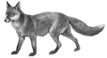
- S - ES čteme IZ

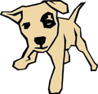

a ……….. two ………… a…………… two……………



a ……….. two…………. a……………. two…………….

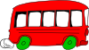

a…………. two…………. a…………….. two……………..


- OO  EE - souhláska + Y  IES


a…………… two………….. a…………….. two………………

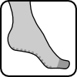

a…………… two…………... a……………... two………………
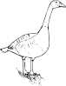
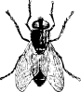

a…………… two…………… a………………. two……………….

- F/FE  VES - stejné j. i množ. číslo

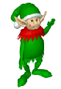

an…………… two…………… a……………… two……………….



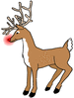
a……………. two…………… a………………. two………………..
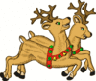
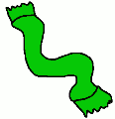

a……………. two…………… a……………….. two………………...

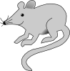
- OUSE  ICE - ES po samohlásce o (u některých podst. jm.)

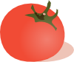

a…………….. two……………. a………………. two…………………
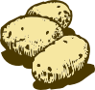

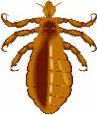

a…………….. two……………. a……………….. three………………..

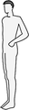
- nepravidelné množné číslo

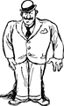
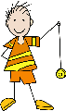
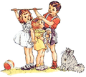
a……………. two……………. a……………….. two………………….


a…………….. three…………… a………………... three…………………
Utvoř množné číslo a doplň do tabulky – make plurals and fill in the box

Cat, party, house, tomato, baby, mouse, shelf, man, deer, match, computer, tooth, child, boss, fish, tomatoe, door, foot, scarf, boy, fly, goose, person, strawberry

- S | - ES | Y - IES | F/FE - VES | OO - EE | Ostatní nepravidelná

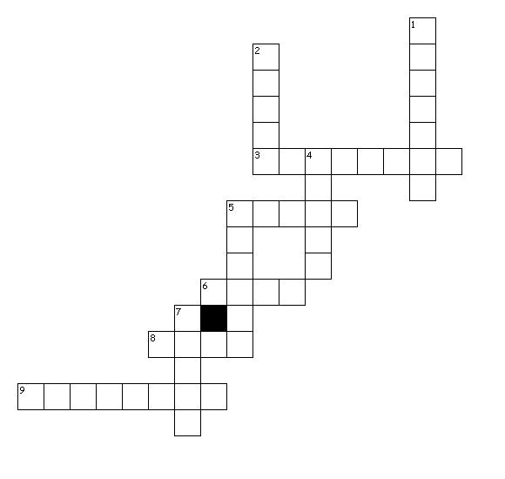
Make plurals and fill in the crossword

Across
3.
5.



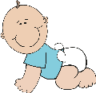
Down
6.
5.

4.

9. 2.
7.
8. 1.

[cit. 2009-27-01]. Dostupné pod licencí Public Domain – na http://www.wpclipart.com/, http://www.clker.com/

http://www.clker.com/clipart-10436.html
http://www.clker.com/clipart-11496.html
http://www.clker.com/clipart-3246.html
http://www.clker.com/clipart-2054.html
http://www.clker.com/clipart-29139.html
http://www.clker.com/clipart-11570.html
http://www.clker.com/clipart-7173.html
http://www.clker.com/clipart-4336.html
http://www.clker.com/clipart-23608.html
http://www.clker.com/clipart-10338.html
http://www.clker.com/clipart-3977.html
http://www.clker.com/clipart-9601.html
http://www.wpclipart.com/animals/dogs/patch.png.html
http://www.wpclipart.com/animals/bugs/L/louse.png.html
http://www.wpclipart.com/clothes/winter_wear/scarf/scarf.png.html
http://www.wpclipart.com/holiday/Christmas/elf/elf_green.png.html
http://www.wpclipart.com/animals/S/sheep/cartoon_sheep_front.png.html
http://www.wpclipart.com/people/baby/baby_3/baby_boy_crawling.png.html
http://www.wpclipart.com/people/baby/baby_3/baby_girl_sitting.png.html
http://www.wpclipart.com/people/male/men_3/man_with_a_bowler_hat.png.html
http://www.wpclipart.com/people/female/women_4/silhouette_female_1.png.html
http://www.wpclipart.com/people/male/men_2/silhouette_male_1.png.html
http://www.wpclipart.com/animals/F/fox/fox_1.png.html
http://www.wpclipart.com/animals/aquatic/fish/_happy_fish.png.html
http://www.wpclipart.com/transportation/car/icons_BW/auto_BW.png.html
http://www.wpclipart.com/plants/leaf/leaf_2/lanceolate_leaf_2.png.html
http://www.clker.com/clipart-23594.html
http://www.wpclipart.com/holiday/Christmas/animals/reindeer_pair.png.html
http://www.wpclipart.com/holiday/Christmas/animals/rudolph2.png.html
http://www.wpclipart.com/people/children/boys/boy_with_yo_yo.png.html
http://www.wpclipart.com/people/children/children_2/kids_how_tall.png.html
http://www.clker.com/clipart-4053.html
http://www.clker.com/clipart-restaurant-waiter.html

KEY

- S - ES čteme IZ

a dog two dogs a fox two foxes

a flower two flowers a box two boxes

a car two cars a bus two buses

- OO  EE - souhláska + Y  IES

a tooth two teeth a family two families

a foot two feet a strawberry two strawberries

a goose two geese a fly two flies

- F/FE  VES - stejné j. i množ. číslo

an elf two elves a fish two fish

a leaf two leaves a sheep two sheep

a scarf two scarf a reindeer two reindeer

- OUSE  ICE - ES po samohlásce o(jen u některých podst.jm)

a…………….. two……………. a tomato two tomatoes

a…………….. two……………. a potato three potatoes

- nepravidelné množné číslo

a woman two women a man two men

a child three children a person three people

Utvoř množné číslo a doplň do tabulky – make plurals and fill in the box

Cat, party, house, tomato, baby, mouse, shelf, man, deer, match, computer, tooth, child, boss, fish, tomatoe, door, foot, scarf, boy, fly, goose, person, strawberry

- S | - ES | Y - IES | F/FE - VES | OO - EE | Ostatní nepravidelná
cats | matches | parties | shelves | teeth | men
computers | boss | babies | lives | feet | deer
houses | tomatoes | flies | scarves | geese | mice
doors |  | strawberries |  |  | children
boys |  |  |  |  | fish
 |  |  |  |  | people
 |  |  |  |  | women

Crossword
Across Down
3. potatoes 1. scarves
5. buses 2. sheep
6. mice 4. teeth
8. dogs 5. babies
9. children 7. women

