FARM ANIMALS – WORD SEARCH
FIND THE WORDS.

BEE | CAT | CHICKEN | COW
DOG | DUCK | GOAT | GOOSE
HEN | HORSE | PIG | ROOSTER
SHEEP | TURKEY

H | E | X | T | U | R | K | E | Y | C
E | L | S | A | D | U | C | K | F | H
N | K | H | J | U | A | L | D | I | I
T | B | E | H | O | M | T | O | N | C
Y | L | E | O | Y | P | I | G/G | A | K
F | J | P | R | X | G | O | O | S | E/E
B | A | I | S | A | B | C | L | D | N
E | C | U | E | G | O | A/A | T | W | O
E | O | A | R | E | E | T | V | Q | L
Q | W | Y | R | O | O | S | T | E | R

LABEL THE PICTURES.
CHOOSE THE NAMES OF THE ANIMALS FROM THE BOX ABOVE.

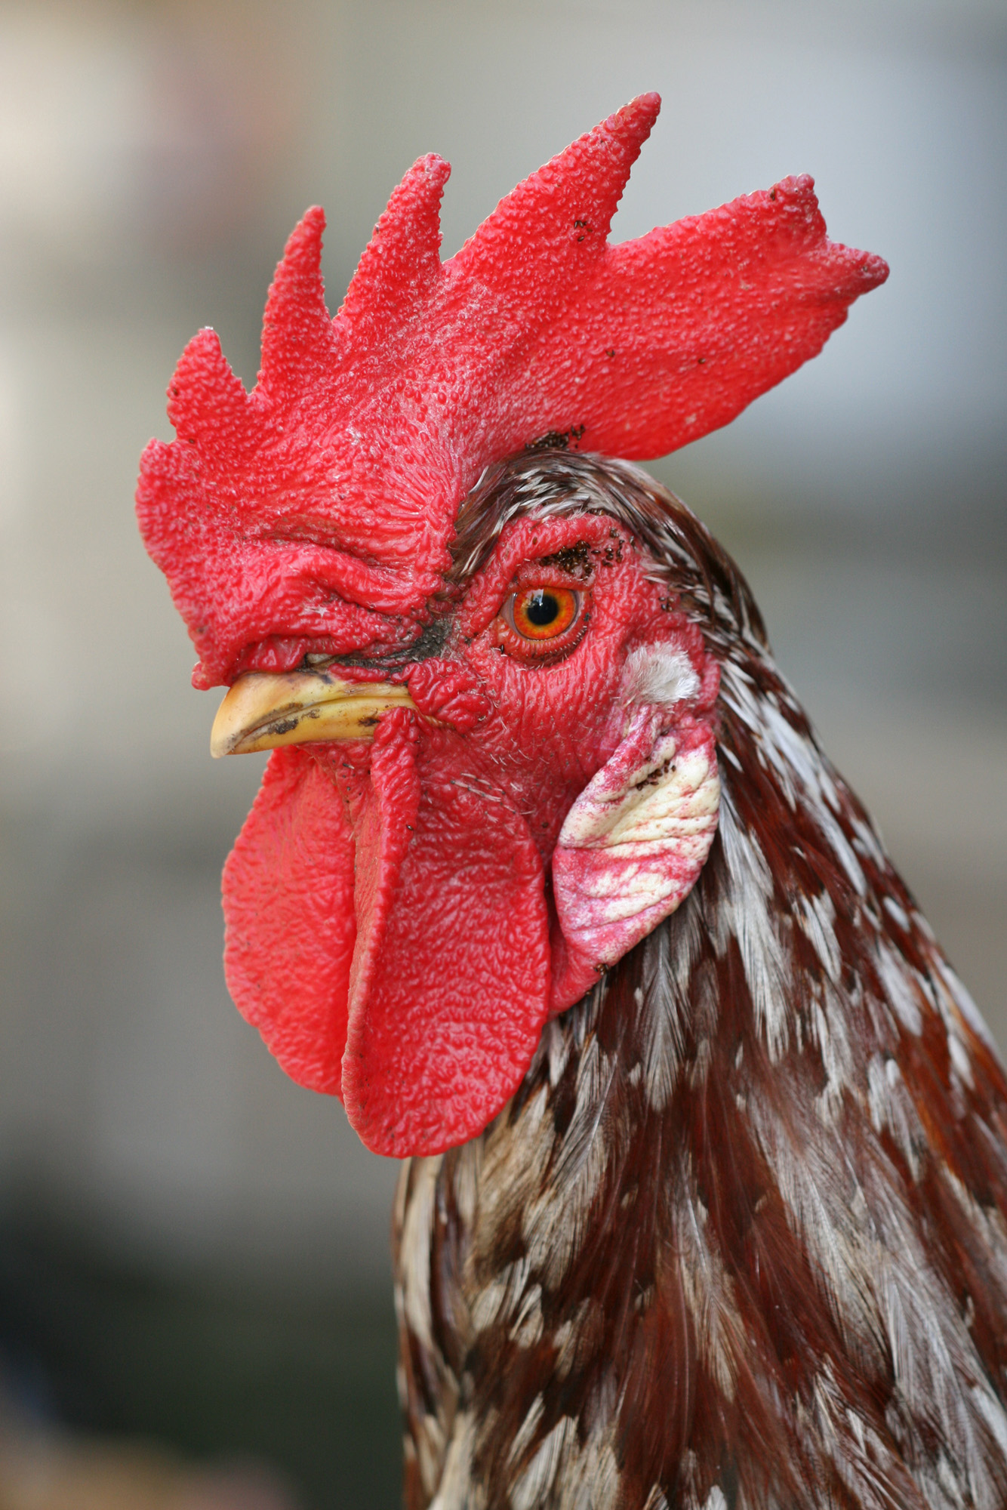 | 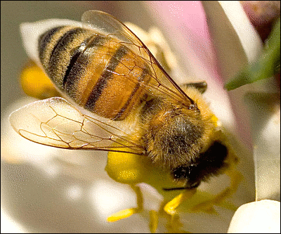 | 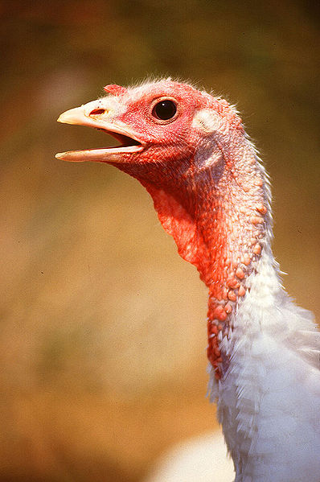
ROOSTER | BEE | TURKEY

Použité obrázky:

kohout | Muhammad Mahdi Karim: Rooster Portrait2.jpg. [cit. 2010-05-06]. Dostupné pod licencí GNU Free Documentation License na WWW: <http://commons.wikimedia.org; http://commons.wikimedia.org/wiki/File:Rooster_portrait2.jpg>.
včela | [cit. 2010-05-06]. Dostupné pod licencí Public Domain na WWW: <http://www.pdclipart.org; http://www.pdclipart.org/displayimage.php?album=search&cat=0&pos=30>.
krocan | Scott Bauer: Large White turkey female.jpg. [cit. 2010-05-06]. Dostupné pod licencí Public Domain na WWW: <http://commons.wikimedia.org; http://commons.wikimedia.org/wiki/File:Large_White_turkey_female.jpg>.

