Pupil A: Read to B.

Rooms in Jason’s house

In my house there are three rooms, a bedroom, a kitchen and a living room.
In my bedroom, there are three beds. There is a wardrobe, too. It’s next to the beds. There is a desk, but there isn’t a table. I do my homework at this desk.
In the middle of the kitchen, there is a round table with four chairs around it. There is also a TV set on the shelf. My mum likes watching TV when she is cooking.
Our living room is very spacious. We have many visitors every weekend. There are two sofas and two armchairs in the middle of the room.

Pupil A: Now listen to B and correct the mistakes in the text.

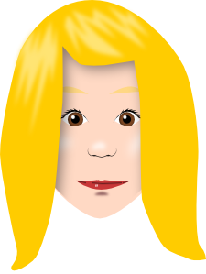’s house

I live in a big family 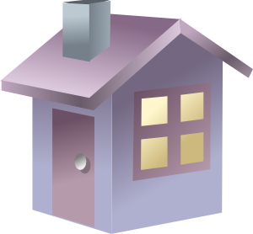. It has got two floors. Upstairs, there are two bedrooms, one for me and one for my little . There is a big bathroom, too. There isn’t a  here, but there is a big shower. There is also a toilet and a washbasin.
Downstairs, there is a hall, a living room and a kitchen. In the living room there is a 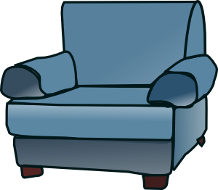 here and there are armchairs, too. The TV set is here. There is a 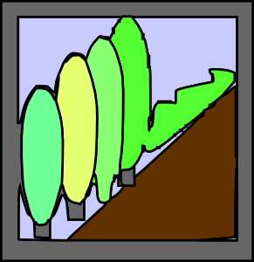 on the desk. I like our fireplace best.
Outside there’s front garden and a garage.

Pupil B: Listen to A and correct the mistakes in the text.

Rooms in Jason’s 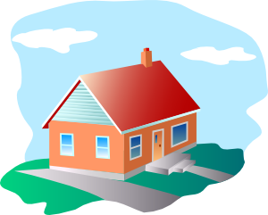

In my house there are three rooms, a bedroom, a kitchen and a living room.
In my bedroom, there are three 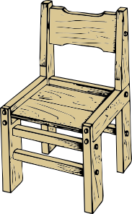 . There is a wardrobe, too. It’s next to the beds. There is a , but there isn’t a table. I do my homework at this desk.
In the middle of the kitchen, there is a round table with four chairs around it. There is also a  on the 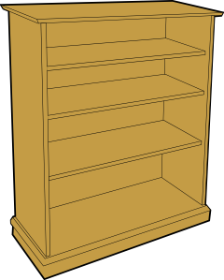. My mum likes watching TV when she is cooking.
Our living room is very spacious. We have many visitors every weekend. There are two 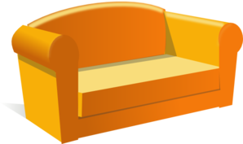 and two armchairs in the middle of the room.

Pupil B: Read to A.

Kelly’s house

I live in a big family house. It has got two floors. Upstairs, there are two bedrooms, one for me and one for my little brother Jack. There is a big bathroom, too. There isn’t a bath here, but there is a big shower. There is also a toilet and a washbasin.
Downstairs, there is a hall, a living room and a kitchen. In the living room there is a sofa here and there are armchairs, too. The TV set is here. There is a computer on the desk. I like our fireplace best.
Outside there’s front garden and a garage.

Použité obrázky:

[cit. 2010–25-06]. Dostupný pod licencí Public Domain na WWW: <http://www.clker.com/clipart-10537.html>.
[cit. 2010–25-06]. Dostupný pod licencí Public Domain na WWW: <http://www.clker.com/clipart-2263.html>.
[cit. 2010–25-06]. Dostupný pod licencí Public Domain na WWW: <http://www.clker.com/clipart-16068.html>.
[cit. 2010–25-06]. Dostupný pod licencí Public Domain na WWW: <http://www.clker.com/clipart-sofa.html>.
[cit. 2010–25-06]. Dostupný pod licencí Public Domain na WWW: <http://www.clker.com/clipart-9412.html>.
[cit. 2010–25-06]. Dostupný pod licencí Public Domain na WWW: <http://www.clker.com/clipart-1837.html>.
[cit. 2010–25-06]. Dostupný pod licencí Public Domain na WWW: <http://www.clker.com/clipart-12190.html>.
[cit. 2010–25-06]. Dostupný pod licencí Public Domain na WWW: <http://www.clker.com/clipart-showers1.html>.
[cit. 2010–25-06]. Dostupný pod licencí Public Domain na WWW: <http://www.clker.com/clipart-9967.html>.
[cit. 2010–25-06]. Dostupný pod licencí Public Domain na WWW: <http://www.clker.com/clipart-cartoon-portrait-frame.html>.
[cit. 2010–25-06]. Dostupný pod licencí Public Domain na WWW: <http://www.clker.com/clipart-24777.html>.

