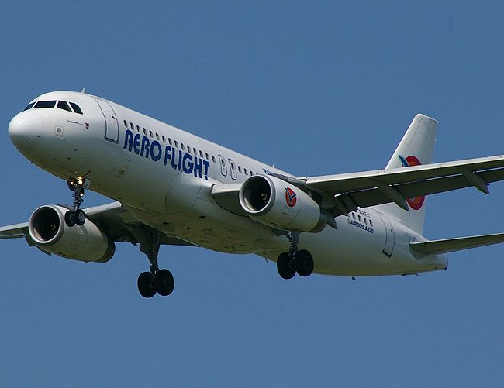 | 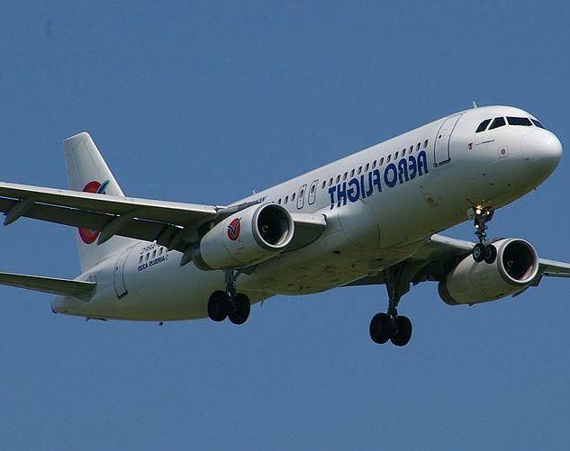
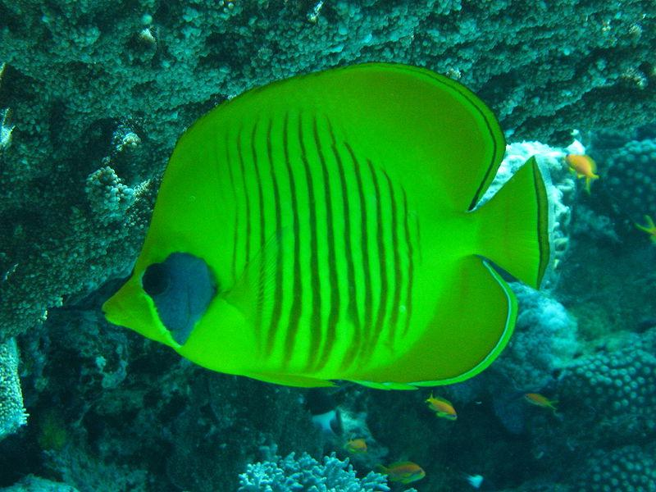 | 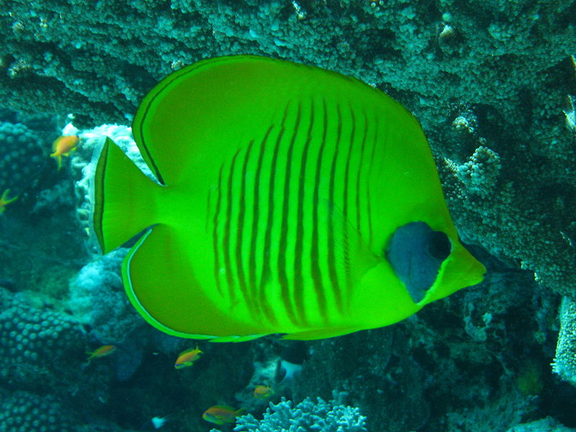
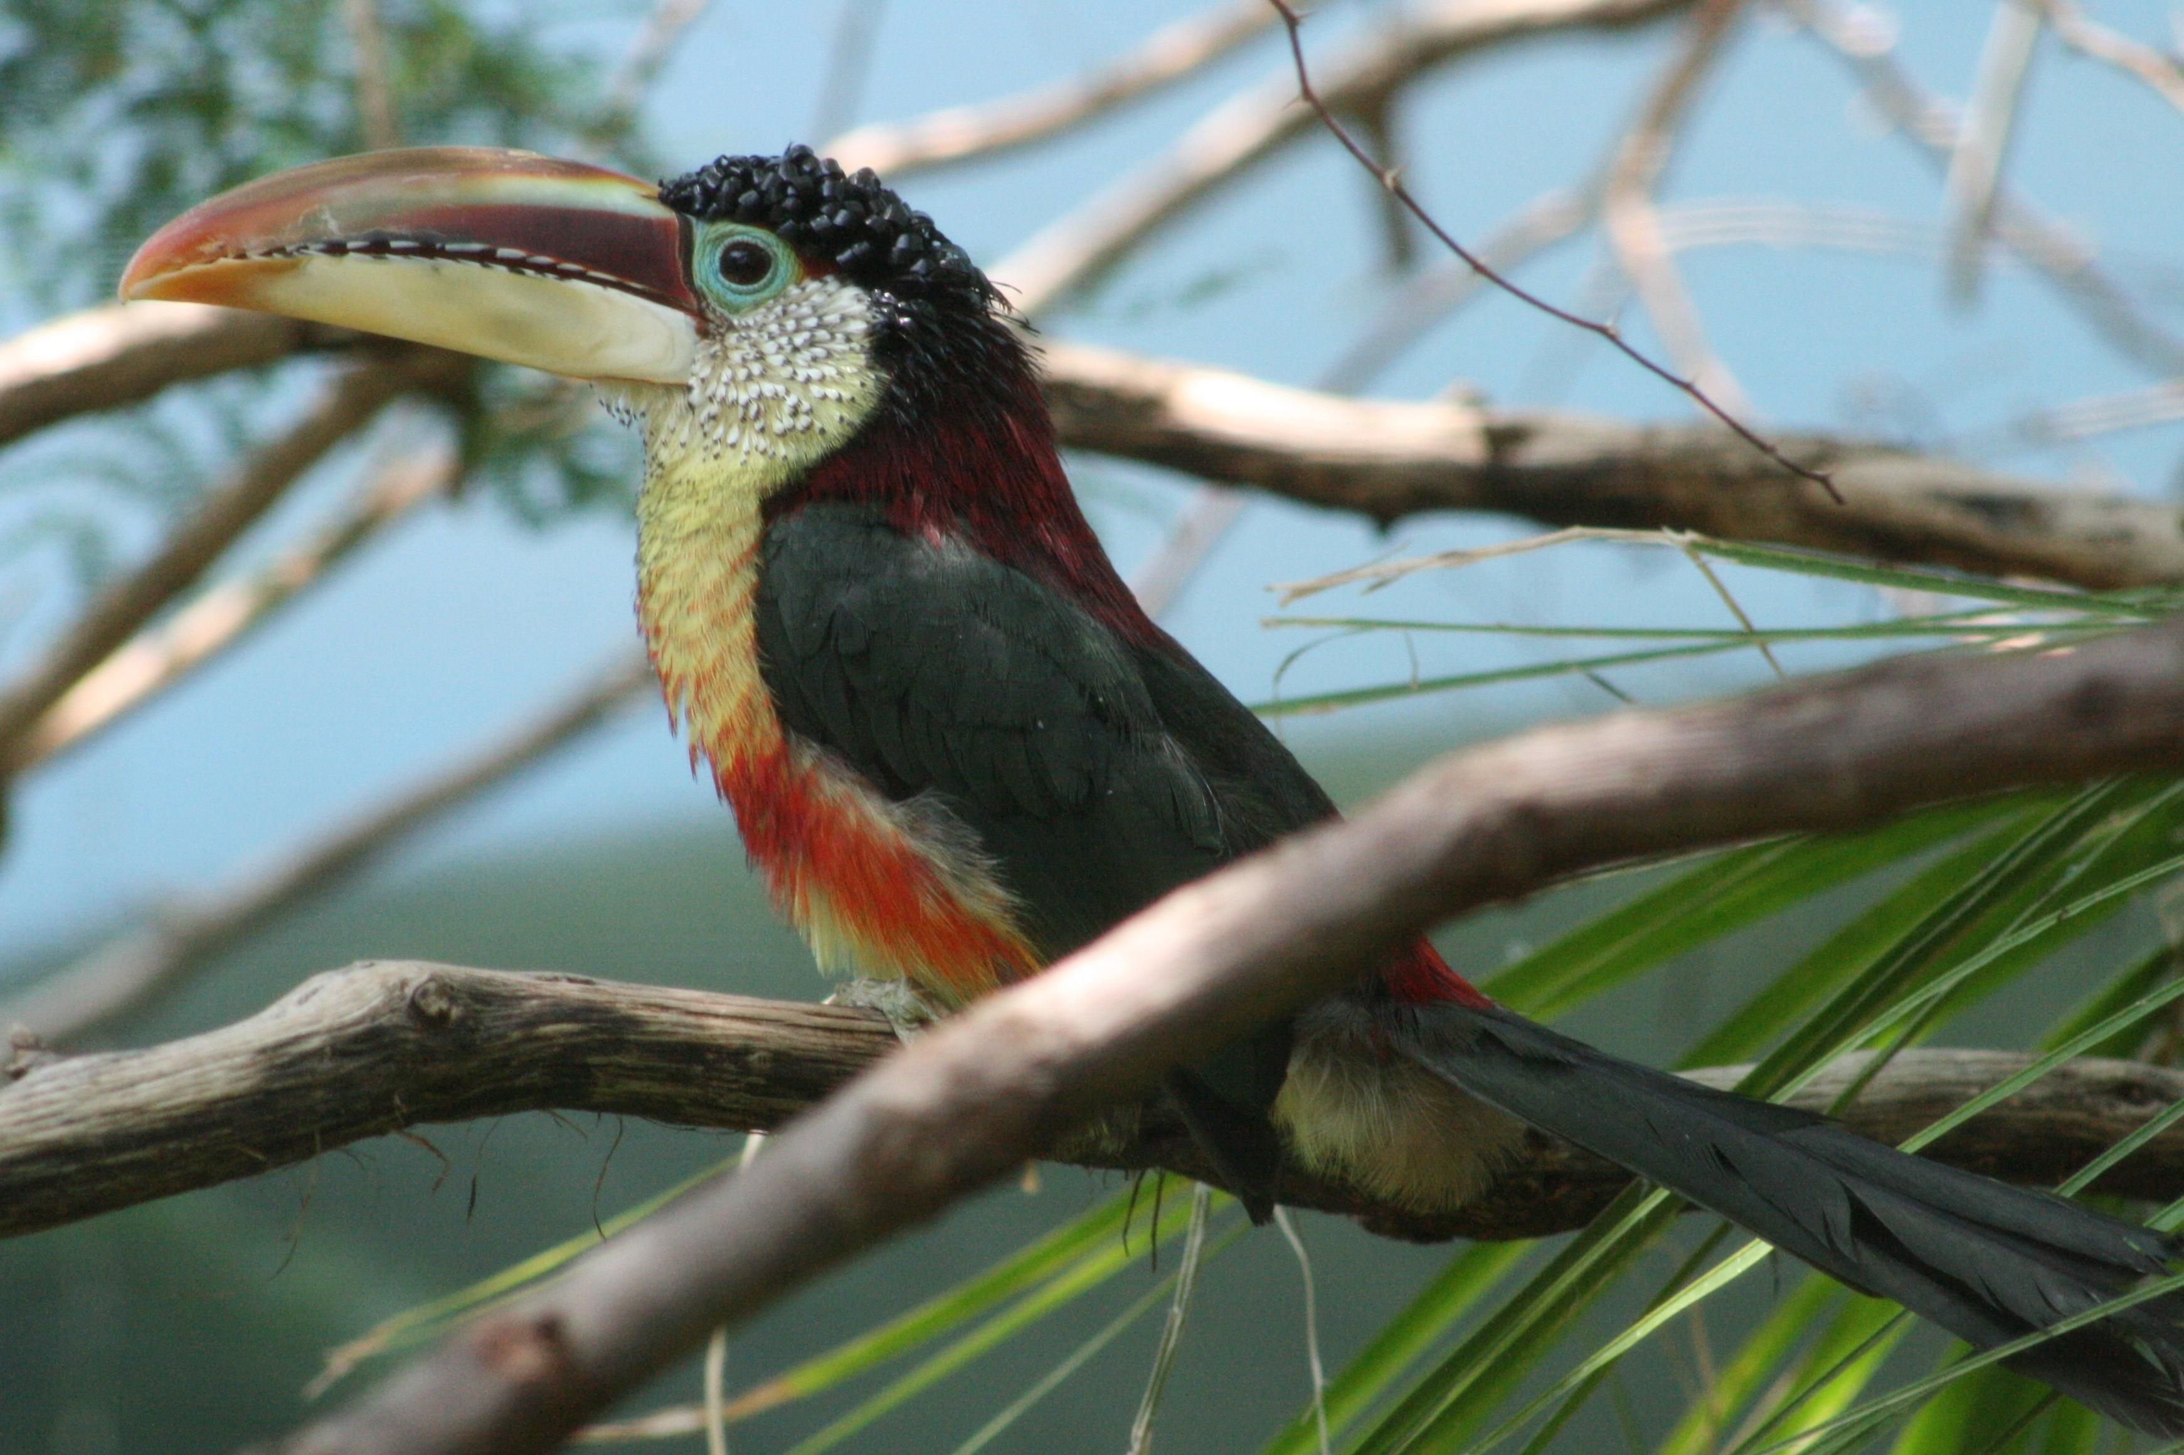 | 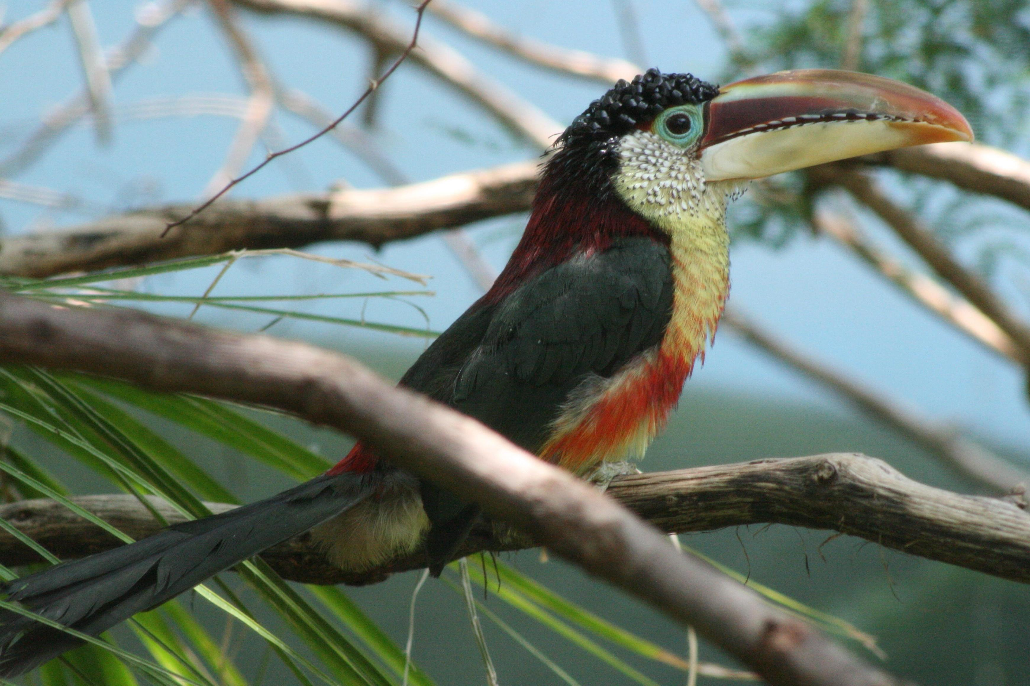
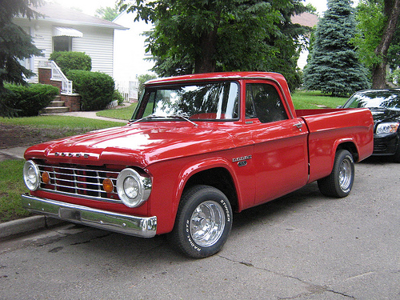 | 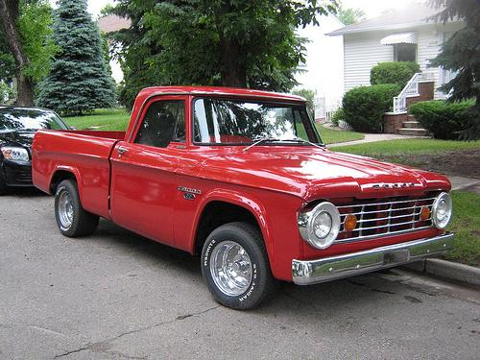
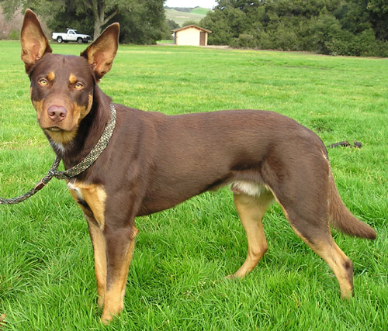 | 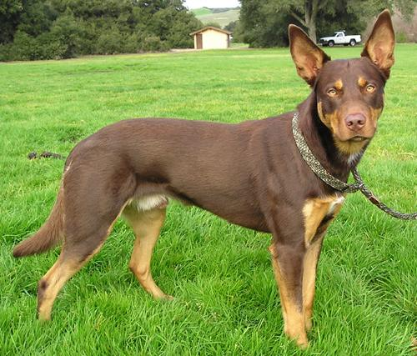
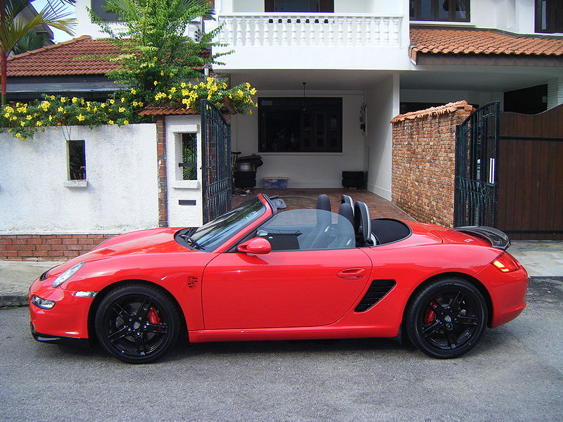 | 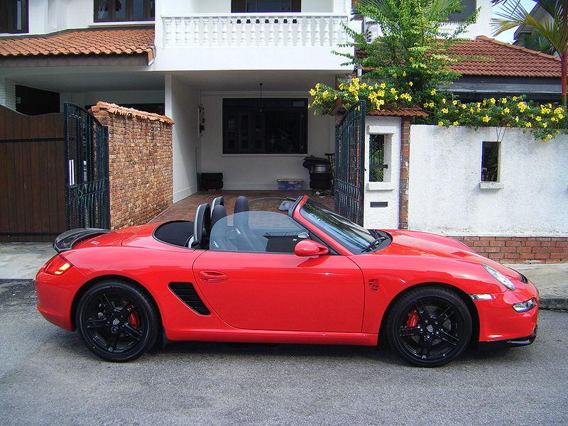
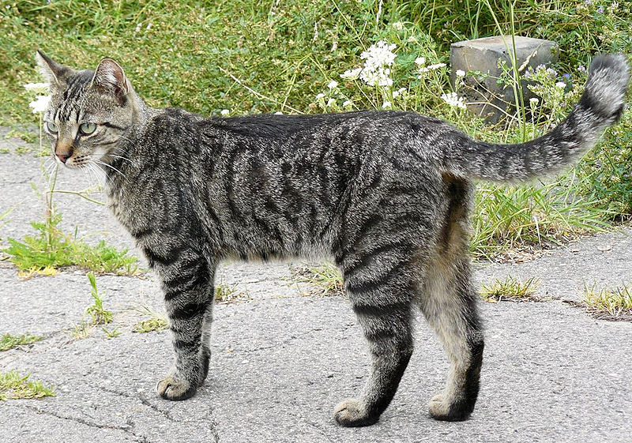 | 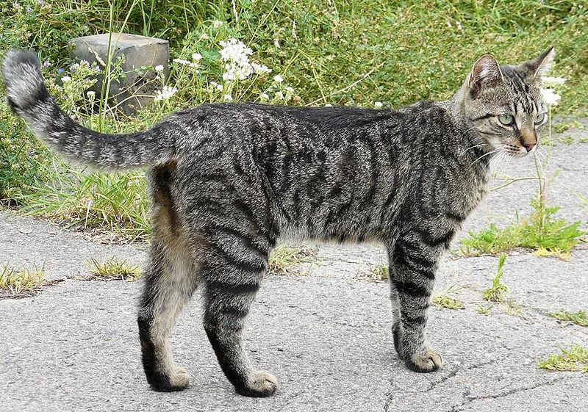
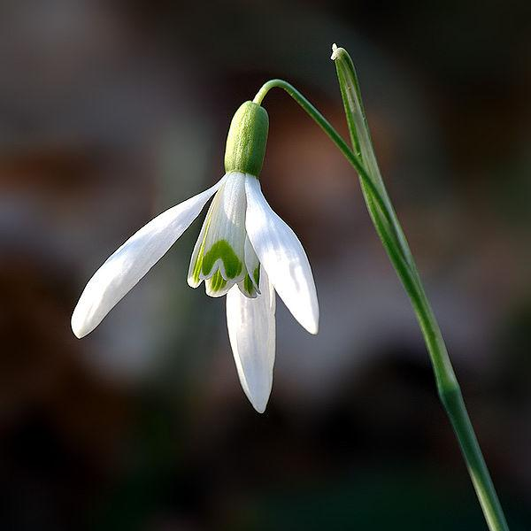 | 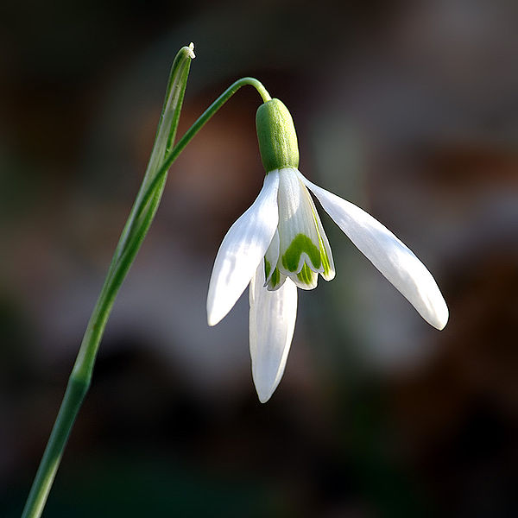
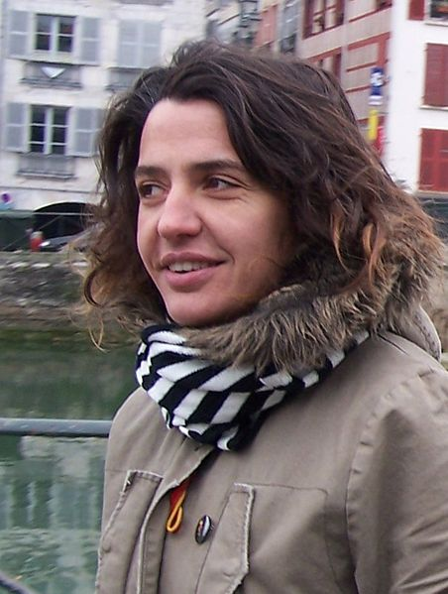 | 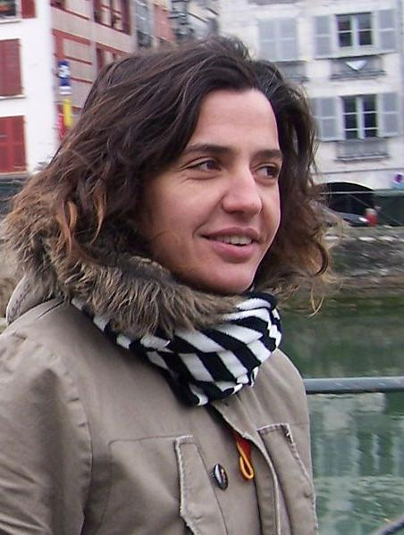
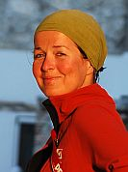 | 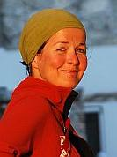
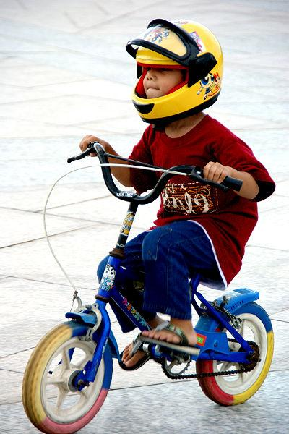 | 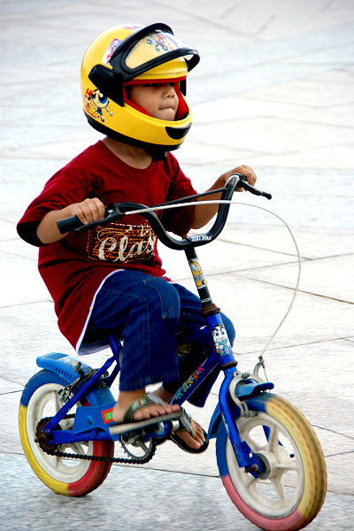
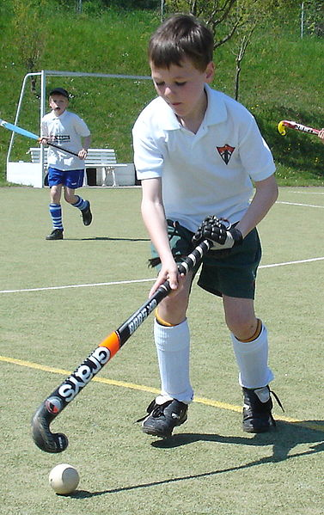 | 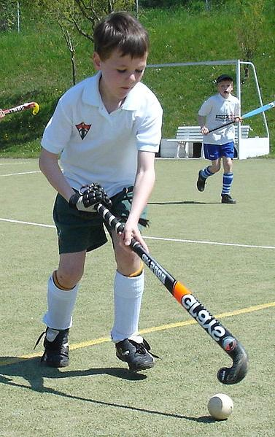

Zdroje obrázků:

http://upload.wikimedia.org/wikipedia/commons/a/a6/Curl-crested_Aracari.jpg
http://upload.wikimedia.org/wikipedia/commons/0/03/Port_Ghalib_march_2006-0103.jpg
http://upload.wikimedia.org/wikipedia/commons/8/86/Agnieszka_zon.jpg
http://upload.wikimedia.org/wikipedia/commons/a/ae/Dodge_500_truck_001.jpg
http://upload.wikimedia.org/wikipedia/commons/a/ac/Aero_Flight_Airbus_A320.jpg
http://upload.wikimedia.org/wikipedia/commons/1/19/Little_boy_without_training_wheels_with_helmet_and_sandals.jpg
http://upload.wikimedia.org/wikipedia/commons/d/d1/Australien_Kelpie.jpg
http://upload.wikimedia.org/wikipedia/commons/6/6d/Galanthus_nivalis_close-up_aka.jpg
http://upload.wikimedia.org/wikipedia/commons/b/b1/Anari.JPG
http://upload.wikimedia.org/wikipedia/commons/6/6a/Boxster_S_GTside.jpg
http://upload.wikimedia.org/wikipedia/commons/thumb/e/e7/Jammlich_crop.jpg/800px-Jammlich_crop.jpg
http://upload.wikimedia.org/wikipedia/commons/7/73/Hockeyspieler_Leonard.jpg

