FARM ANIMALS
WRITE THE NAMES OF THE ANIMALS.
THEN MATCH THE NAMES OF THE ANIMALS WITH THE CORRECT PICTURES.

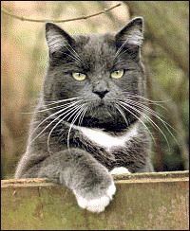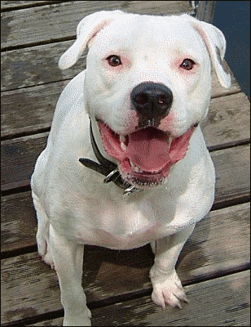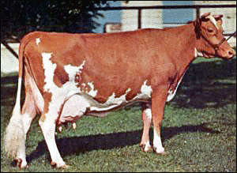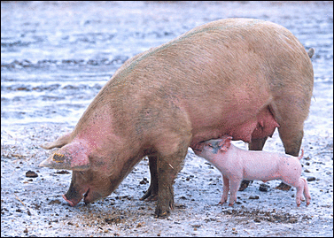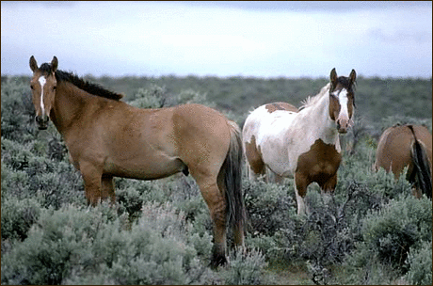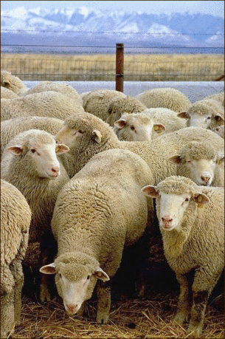
E R
O
S H
W O
C
O D
G
T C
A
G I
P
P E
S
E H
HORSE
COW
CAT
PIG
SHEEP
DOG

MORE FARM ANIMALS
DRAW AND WRITE THE NAMES OF 3 MORE FARM ANIMALS.
USE A DICTIONARY TO LOOK UP NEW WORDS.
EXAMPLES
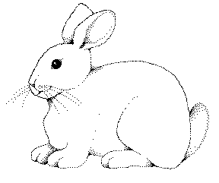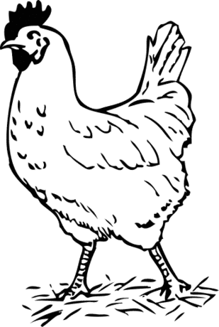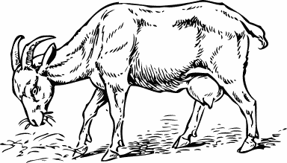
RABBIT
ROOSTER
GOAT
Použité obrázky:

kočka | [cit. 2010-05-06]. Dostupné pod licencí Public Domain na WWW: <http://www.pdclipart.org/displayimage.php?album=search&cat=0&pos=80>.
kráva | [cit. 2010-05-06]. Dostupné pod licencí Public Domain na WWW: <http://www.pdclipart.org/displayimage.php?album=search&cat=0&pos=43>.
ovce | [cit. 2010-05-06]. Dostupné pod licencí Public Domain na WWW: <http://www.pdclipart.org/displayimage.php?album=search&cat=0&pos=10>.
vepř | [cit. 2010-05-06]. Dostupné pod licencí Public Domain na WWW: <http://www.pdclipart.org/displayimage.php?album=search&cat=0&pos=4>.
pes | [cit. 2010-05-06]. Dostupné pod licencí Public Domain na WWW: <http://www.pdclipart.org/displayimage.php?album=search&cat=0&pos=9>.
kůň | [cit. 2010-05-06]. Dostupné pod licencí Public Domain na WWW: <http://www.pdclipart.org/displayimage.php?album=search&cat=0&pos=0>.
králík | [cit. 2010-05-06]. Dostupné pod licencí Public Domain na WWW: <http://www.pdclipart.org/displayimage.php?album=search&cat=0&pos=8>.
kohout | [cit. 2010-05-06]. Dostupné pod licencí Public Domain na WWW: <http://www.pdclipart.org/displayimage.php?album=search&cat=0&pos=2>.
koza | [cit. 2010-05-06]. Dostupné pod licencí Public Domain na WWW: <http://www.pdclipart.org/displayimage.php?album=search&cat=0&pos=7>.

