- Culture

- Two girls met in front of the National Theatre. They talked about culture, films, music and things like that. Write down these sentences in the correct order.

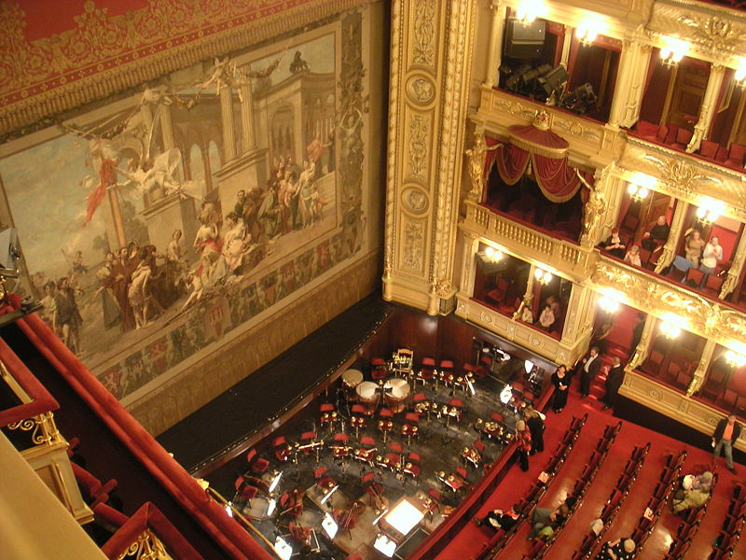
Yes, I was.
Thank you very much.
How are you? Glad to see you.
Yes, I’d like to see it.
It’s great. How much are they?
No, I wasn’t. It was sold out.
Hello, how are you?
Enjoy it!
Would you like to see this play?
I can get you two tickets.
They are free. It’s present for you.
Were you at the theatre?
And you?

- _______________________________________________________
- _______________________________________________________
- _______________________________________________________
- _______________________________________________________
- _______________________________________________________
- _______________________________________________________
- _______________________________________________________
- _______________________________________________________
- _______________________________________________________
- _______________________________________________________
- _______________________________________________________
- _______________________________________________________
- _______________________________________________________
- Match the sentences.

Where is it on? Rock and Roll.
Can you play the piano? Twice a week.
How often do you practise? At the National Theatre.
Did you enjoy it? Shrek III.
What’s on at the Star cinema? A little bit.
What kind of music do you prefer? No, it was boring.

- Write these words to the crossword: violin, cello, piano, harp, guitar, flute, trumpet, drum, triangle, harmonica, viola, tuba, organ, pipes.

Obrázek pochází ze stránky http://commons.wikimedia.org/wiki/File:Nationaltheater_von_innen_(B%C3%BChnenbild).JPG

Culture - řešení
- Two girls met in front of the National Theatre. They talked about culture, films, music and things like that. Write down these sentences in the correct order.
Hello, how are you?
How are you? Glad to see you.
Were you at the theatre?
Yes, I was.
And you?
No, I wasn’t. It was sold out.
Would you like to see this play?
Yes, I’d like it.
I can get you two tickets.
It’s great. How much are they?
They are free. It’s present for you.
Thank you very much.
Enjoy it!

- Match the sentences.
Where is it on? At the National Theatre.
Can you play the piano? A little bit.
How often do you practise? Twice a week.
Did you enjoy it? No, it was boring.
What’s on at the Star cinema? Shrek III.
What kind of music do you prefer? Rock and Roll.

- Fill these words to the crossword: violin, cello, piano, harp, guitar, flute, trumpet, drum, triangle, harmonica, viola, tuba, organ, pipes.
 |  |  |  |  |  |  |  |  |  |  | V
P |  |  |  |  |  | T |  |  |  | P | I | P | E | S
I |  |  |  |  | D | R | U | M |  |  | O
A |  |  |  |  |  | U |  |  |  |  | L
N |  |  | H | A | R | M | O | N | I | C | A
O | R | G | A | N |  | P |  |  |  |  |  |  |  |  | G
 |  |  | R |  |  | E |  | V |  |  |  | F |  |  | U
 |  |  | P |  |  | T | R | I | A | N | G | L | E |  | I
 |  |  |  |  |  |  |  | O |  |  |  | U |  |  | T
 |  |  |  |  | C | E | L | L | O |  |  | T | U | B | A
 |  |  |  |  |  |  |  | I |  |  |  | E |  |  | R
 |  |  |  |  |  |  |  | N

