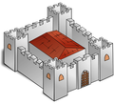
Buildings and dwellings

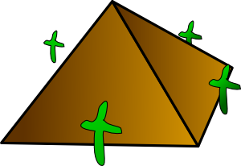
Make words and match them with the pictures


1) FAC EUM ……………………..


2) LIGHT RESS ……………………..


3) CA SCRAPER ……………………..


4) CHU TAGE ……………………..

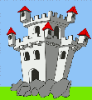
5) PYR TORY ……………………...

6) SKYS USE ……………………...


7) COT HOUSE ……………………...


8) WIND PEE ………………………
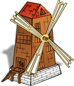

9) MUS DRAL ………………………

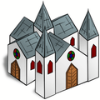
10) IG AMID ………………………


11) TEE STLE ……………………….


12) PRE LOO ……………………….
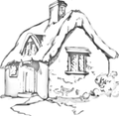

13) FORT RCH ……………………….


14) CATHE FAB ……………………….

15) HO MILL ……………………….

Fill in the missing letters and draw a picture
P_ _F_B S_Y_ _R_P_R

_EE_ _E _ _R_M_D

_OU_ _ L_G_TH_ _S_

Unscramble the letters

- Jim lives in a yellow ………………….. . (sohue)
- There are a lot of …………………….. in New York. (kysacrepsrs)
- Eskimos live in ……………………… . (soloig)
- My father works in a…………………… . (rycotfa)
- We go to that…………………….. on Sunday. (hcuchr)
- We have a……………………….in the country. (gecatot)
- Princesses live in a……………………… . (lastce)
- Indians live in a………………………. (eteepe)
- You can see a mummy in the…………………… . (suemum)
- I live in a grey……………………….. . (febrap)

[cit. 2009-27-01]. Dostupné pod licencí Public Domain – na http://www.clker.com/, http://www.wpclipart.com/

http://www.wpclipart.com/buildings/lighthouse/lighthouse.png.html
http://www.wpclipart.com/buildings/homes/tepee.png.html
http://www.wpclipart.com/buildings/homes/homes_2/igloo.png.html
http://www.wpclipart.com/buildings/factory/factory.png.html
http://www.wpclipart.com/buildings/famous/US_famous/Empire_State_Building.png.html
http://www.wpclipart.com/buildings/assorted/assorted_2/Windmill.png.html
http://www.wpclipart.com/buildings/assorted/assorted_4/museum_symbol.png.html
http://www.wpclipart.com/buildings/castle/fortress.png.html
http://www.wpclipart.com/buildings/castle/castle.png.html
http://www.clker.com/clipart-10269.html
http://www.wpclipart.com/buildings/church/church.png.html
http://www.wpclipart.com/buildings/church/cathedral.png.html
http://www.wpclipart.com/buildings/city/brownstone.png.html
http://www.wpclipart.com/buildings/homes/house/small_house.png.html
http://www.wpclipart.com/buildings/rural/cottage.png.html

Buildings and dwellings

Make words and match them with the pictures

1) FACTORY

2) LIGHTHOUSE

3) CASTLE

4) CHURCH

5) PYRAMID

6) SKYSCRAPER

7) COTTAGE

8) WINDMILL

9) MUSEUM

10) IGLOO

11) TEEPEE

12) PREFAB

13) FORTRESS

14) CATHEDRAL

15) HOUSE

Fill in the missing letters and draw a picture
PREFAB SKYSCRAPER

TEEPEE PYRAMID

HOUSE LIGHTHOUSE

Unscramble the letters

- Jim lives in a yellow HOUSE. (sohue)
- There are a lot of SKYSCRAPERS in New York. (kysacrepsrs)
- Eskimos live in IGLOOS. (soloig)
- My father works in a FACTORY. (rycotfa)
- We go to that CHURCH on Sunday. (hcuchr)
- We have a COTTAGE in the country. (gecatot)
- Princesses live in a CASTLE. (lastce)
- Indians live in a TEEPEE. (eteepe)
- You can see a mummy in the MUSEUM. (suemum)
- I live in a grey PREFAB. (febrap)

