LOOK AT THE PICTURES. NAME THEM. READ THE DESCRIPTIONS BELOW AND MATCH THE SENTENCES TO THE PICTURES. THERE ARE SOME EXTRA DESCRIPTIONS.

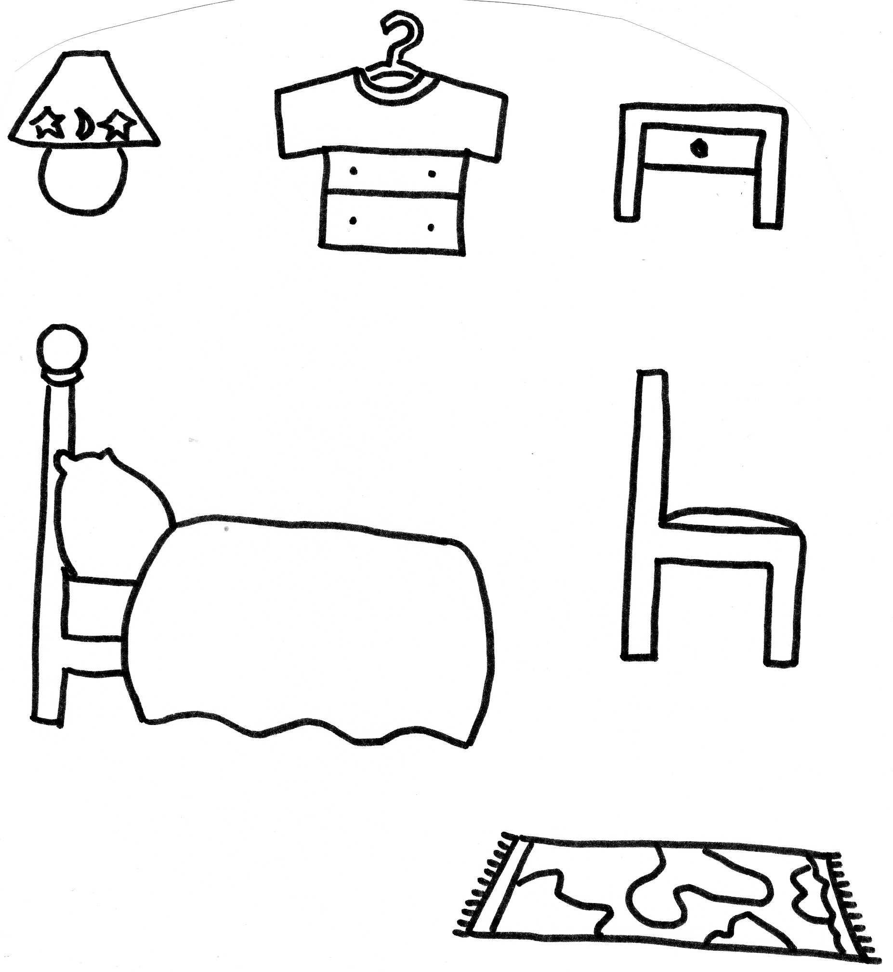

Autor © Dagmar Csatová

WE CAN SIT ON THIS AT THE TABLE. | YOU CAN HANG YOUR COAT OR A T-HIRT ON THIS.
IT IS A SMALL LIGHT NEXT TO OUR BED. | WE PUT MILK IN THIS.
WE CAN USE THIS TO EAT BREAKFAST. | YOU CAN COOK IN THE KITCHEN ON THIS.
IT IS NEXT TO OUR BED. YOU CAN PUT A BOOK OR AN ALARM CLOCK ON IT. | THIS IS A ROOM WHERE WE SLEEP.
YOU CAN SLEEP ON IT. | IT IS ON THE FLOOR, YOU CAN SIT ON THIS.

ŘEŠENÍ:

WE CAN SIT ON THIS AT THE TABLE. | YOU CAN HANG YOUR COAT OR A T-HIRT ON THIS.
IT IS A SMALL LIGHT NEXT TO OUR BED. | WE PUT MILK IN THIS.
IT IS ON THE FLOOR, YOU CAN SIT ON THIS. | YOU CAN COOK IN THE KITCHEN ON THIS.
IT IS NEXT TO OUR BED. YOU CAN PUT A BOOK OR AN ALARM CLOCK ON IT. | THIS IS A ROOM WHERE WE SLEEP.
YOU CAN SLEEP ON IT. | WE CAN USE THIS TO EAT BREAKFAST.

