HOUSING
House
roof
chimney dustbin
skylight yard
window sill terrace
shutter garage
front door balcony
doormat letterbox
doorbell doorknob

Kitchen Bathroom
fitted kitchen shower unit
cupboard bath
kitchen cabinet washbasin
cooker tap
oven vanity cabinet
cooker hood shelf
sink mirror
dish drainer towel
dishwasher towel rail
washing machine bath mat
microwave oven plug
refrigerator/fridge toilet
freezer
pantry

Living room Bedroom
sofa double bed
armchair eiderdown
coffee table pillow
chandelier bedspread
fireplace bedside table
mantelpiece alarm clock
furniture wardrobe
wall unit chest of drawers
cabinet radiator
display cabinet
bookcase
television, TV set Hall
home stereo shoe cabinet
home theatre coat-rack
parquet floor
floating floor
carpet
rug
wallpaper
curtain
net curtain
roller blind
venetian blind
Kitchen utensil At the table
dishes tableware
bowl dinner plate
pot soup plate
frying pan dessert plate
saucepan cup and saucer
roasting tin mug
cover/lid glass
wooden spoon jug
ladle cutlery
potato masher knife
egg slicer fork
whisk spoon
sieve napkin
tea-strainer tablecloth
colander place mat
grater ashtray
funnel
corkscrew
garlic press
meat tenderizer
chopping board
tray
rolling pin
kitchen timer
kitchen scales
measuring jug
oven glove

Domestic appliances
mincer
coffee grinder
microwave oven
(high-speed electric) kettle
toaster
sandwich maker
deep-fryer
blender
food processor
juicer (extractor)
coffee maker

Translate the words and find out furniture

- byl + H + v + GMAC + ahoj + NE
- S + jak +E + běhat + IT
- válka + D + šat
- C + ruka + E + ležet + R
- paže + C + vlasy
- auto + mazlíček
- C + nahoru + B + veslo + D
- P + nemocný + OW
- netopýr + H + žíněnka
- postel + SP + číst

Which one is odd?

- cooker vanity cabinet oven sink blender
- sofa armchair basin display cabinet coffee table
- mirror soap towel chandelier bath
- teapot curtain bowl plate saucer
- fork shelf knife spoon cutlery
- pillow rug sheet eiderdown bedspread
- fridge freezer kettle dishwasher mug

Write the words according to the description

- A piece of furniture with shelves, where you put books. …………….
- A piece of thick material that covers the floor. …………….
- The upper part of the room, the light usually hangs on it. …………….
- A place in the room where you can light a fire. …………….
- A small kind of carpet which doesn´t cover the whole floor. …………….
- A piece of furniture where you can get rid of the waste material in your body………….
- You keep foods in this, so that they don´t go off. …………….
- A wooden box with shelves where you put shoes. …………….
- A kitchen appliance in which you can bake or roast. …………….
- A soft and comfortable chair. People usually sit in it in the living room. …………….
- You keep your glasses and mugs in it. …………….
- You can see your face if you look in this. …………….
- If you don´t want to wash the dishes yourself you can use this. ……………
- A bowl fixed to the bathroom wall. It´s used for washing. …………….
- You keep your clothes in this big type of furniture. …………….

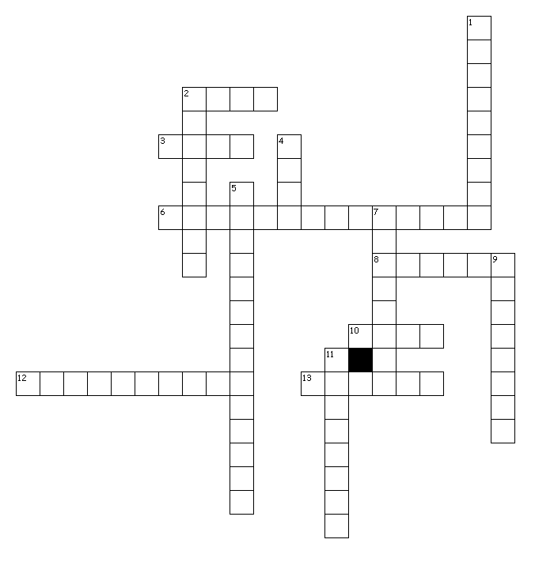
Fill in the crossword

Across Down

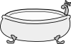
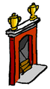
2.

1.
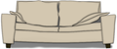
3.

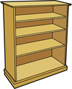
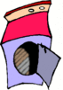
6. 2.

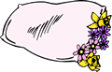
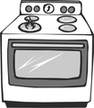

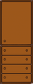
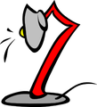
8.
10.
4.

5.

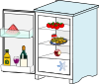
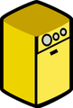
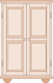

9.
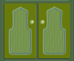
12.

- 7.
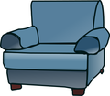
11.
T_I_ _ T
_A_ _ _ _O_
B_ _ _ _ _M
_I_ _ _ _N
_A_ _
_I_I_ _ _ _ _M
BA _H
T_W_L
B_S_N
S_ _W_R U_ _T
_I_ _OR
_H_ _F
VAN_ _Y C_ _I_ ET
_A_H M_T
D_ _B_E _ED
W_ _D_ _ _E
C_E_T OF D_ _W_ _S
P_L_ _W
SH_ _T
E_DE_D_W_
CAR_ _T
B_ D_ _ _E T_ _LE
S_ _E C_ _I_ _T
C_A_R_CK
S_F_
_HA_ _E_I_R
A_ _C_AIR
C_FF_ _ T_B_ _
_ALL U_I_
_
B_ _KC_ _E
C_RT_ _N
H_M_ T_EA_R_
F_R_PL_ _E
W_LL_AP_R
F_T_ED KI_C_ _N
D_ _HW_ _ _ER
W_ _ _IN_ M_ _H_N_
S_NK
_V_N
C_ _K_R
F_EE_ER
_R_DG_
C_PB _AR_
M_CR_ _ _ _E O_EN
_UG
HOUSE

[cit. 2009-27-01]. Dostupné pod licencí Public Domain – na http://www.pdclipart.org/, http://www.clker.com/.

http://www.wpclipart.com/household/living_room/fireplace.png.html
http://www.wpclipart.com/household/kitchen/kitchen_5/dish_washer.png.html
http://www.wpclipart.com/household/kitchen/kitchen_5/gas_oven_large_BW.png.html
http://www.wpclipart.com/household/furniture/desk_lamp.png.html
http://www.wpclipart.com/household/furniture/chair/armchair_2.png.html
http://www.wpclipart.com/household/furniture/more_furniture/couch.png.html
http://www.wpclipart.com/household/furniture/more_furniture/wooden_bookcase_color.png.html
http://www.wpclipart.com/household/chores/laundry/washing_machine_2.png.html
http://www.clker.com/clipart-25460.html
http://www.clker.com/clipart-11024.html
http://www.clker.com/clipart-28935.html
http://www.clker.com/clipart-11238.html
http://www.clker.com/clipart-24286.html
http://www.wpclipart.com/household/bedroom/Pillow_7.png.html

KEY
Translate the words and find out furniture
- washing machine
- shower unit
- wardrobe
- chandelier
- armchair
- carpet
- cupboard
- pillow
- bath mat
- bedspread

Which is one odd?
- vanity cabinet
- basin
- chandelier
- curtain
- shelf
- rug
- mug

Write the words according to the description
- bookshelf
- carpet
- ceiling
- fireplace
- rug
- toilet
- fridge
- shoe cabinet
- oven
- armchair
- cupboard
- mirror
- dishwasher
- basin
- wardrobe

Crossword
Across Down
2) bath 1) fireplace
3) sofa 2) bookcase
6) washing machine 4) oven
8) pillow 5) chest of drawers
10) lamp 7) cupboard
12) dishwasher 9) wardrobe
13) fridge 11) armchair
Toilet
Bathroom
Bedroom
Kitchen
Hall
Living room
Bath
Towel
Basin
Shower unit
Mirror
Shelf
Vanity cabinet
Bath mat
Double bed
Wardrobe
Chest of drawers
Pillow
Sheet
Eiderdown
Carpet
Bedside table
Shoe cabinet
Coatrack
Sofa
Chandelier
Armchair
Coffee table
Wall unit
_
Bookcase
Curtain
Home theatre
Fireplace
Wallpaper
Fitted kitchen
Dishwasher
Washing machine
Sink
Oven
Cooker
Freezer
Fridge
Cupboard
Microwave oven
Rug
HOUSE
Tip! Jak použít paměťovou mapu? Učitel může zadat slohovou práci (můj dům/byt), nebo si na základě mapy žáci zpracují popis svého bytu ústně.

