Easter game – pracovní list 2

Vybarvi vajíčka podle zadání:

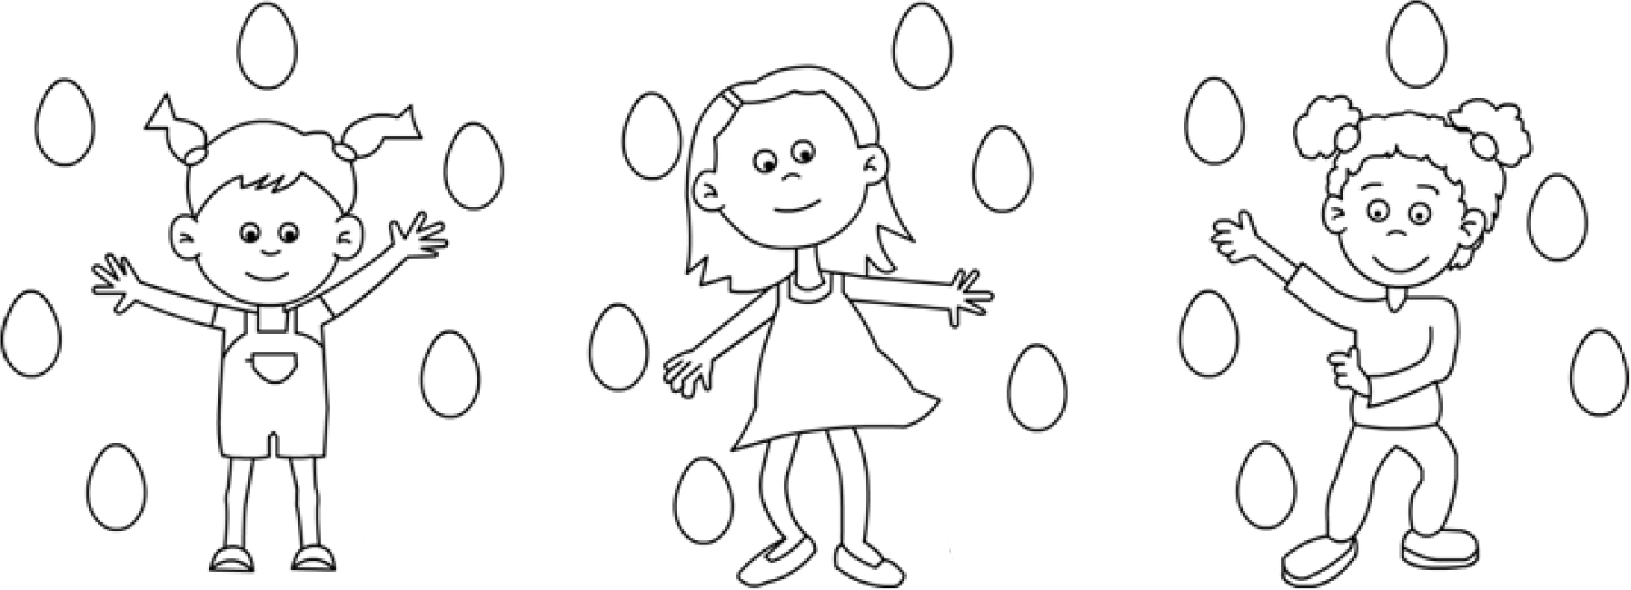

Ann has got two green eggs. Sue has got three red eggs. Nicky has got one blue egg.

Ann has got one yellow egg. Sue has got one pink egg. Nicky has got four orange eggs.

Ann has got three brown eggs. Sue has got two purple eggs. Nicky has got one white egg.

Odpověz na otázky:

How many purple eggs has Sue got? _________________________________________________

How many orange eggs has Nicky got? _________________________________________________

How many green eggs has Ann got? _________________________________________________

What´s this?






_______________ _______________ ______________ ___________________ ___________________

Připoj obrázek ke slovíčku:

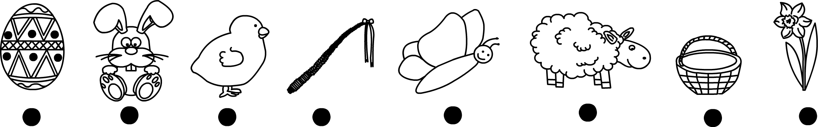

bunny | chicken | stick | egg | sheep | basket | butterfly | flower

Doplň, kolik věcí je na obrázku – slovem:


