TRANSPORT AND TRAVELLING

Fill in the missing letters of the means of transport

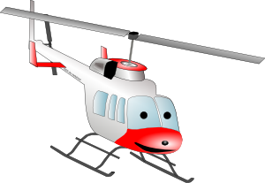HE_IC_PT_R  _ _AIN

 FE_ _Y 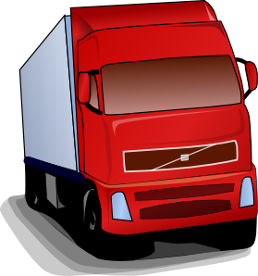 _RUC_

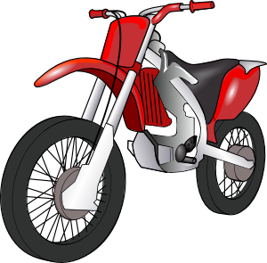 _O_O_ _I_E  Y_CH_
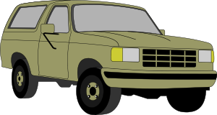 _ _ _  TR_M

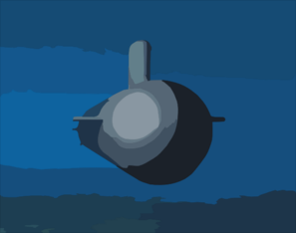 S_BM_RIN_ 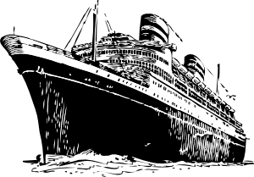 OC_ _N LI_ER

 C_ _ _H

What travels on land?

What travels on water?

What travels under water?

What travels in the air?

Can you add some more vehicles into each category?
Answers:

helicopter, train, ferry, truck, motorbike, yacht, car, tram, submarine, ocean liner, coach

What travels on land? train, truck, motorbike, car, tram, coach, camper van, ambulance, lorry, bus, van, pick up truck, caravan, bicycle……
What travels on water? ferry, yacht, ocean liner, ship, fishing boat, steamer…..
What travels under water? submarine
What travels in the air? helicopter, plane, balloon, jet…..

You can present new vocabulary by using flash cards. It’s good to have „water”, „land” etc. flash cards as well. I usually display them around the classroom and children that are divided into teams have to categorize the means of transport as quickly as possible. They don’t have picture flash cards, only the names of the vehicles or a little description (for more skilled students). At the end of the lesson you can revise new vocabulary like this: For example, you can write “helicopter” on the board like this:

H
E
L
I
C
O
P
T
E
R

and children have to think of any vehicle for each letter. The word can begin or end with the letter or the letter is part of the word.

S HIP
SL EIGH
LORRY
B IKE
CAR
B OAT
PLANE
TRAM
ST EAMER
T RAIN
Všechny uveřejněné odkazy [cit. 2010–05–06] jsou dostupné pod licencí Public Domain na www:
<http://www.clker.com/clipart-29758.html> – helikoptéra
<http://www.clker.com/clipart-6856.html> – vlak
<http://www.clker.com/clipart-14421.html> – trajekt
<http://www.clker.com/clipart-3037.html> – nákladní auto
<http://www.clker.com/clipart-11991.html> – motorka
<http://www.clker.com/clipart-6933.html> – jachta
<http://www.clker.com/clipart-2992.html> – auto
<http://www.clker.com/clipart-3063.html> – tramvaj
<http://www.clker.com/clipart-conceptual-drawing-shows-the-new-virginia-class-attack-submarine.html> – ponorka
<http://www.clker.com/clipart-10445.html> – zaoceánská loď
<http://www.clker.com/clipart-3043.html> – autobus

