READ AND MATCH. NUMBER THE PICTURES.
WRITE THE NAMES OF THE ANIMALS.

1  I live in Africa. I have four long legs and a very long neck.  GIRAFFE | 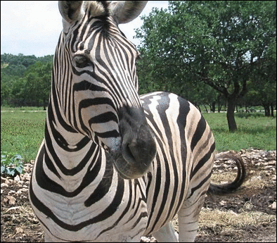  5  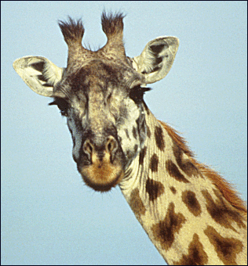  1  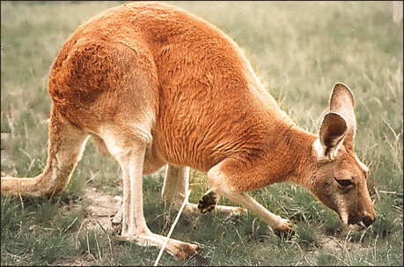  6  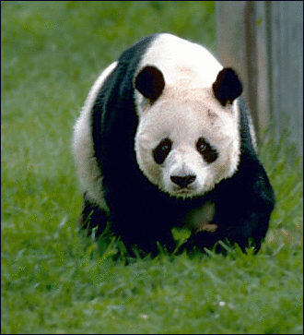  3  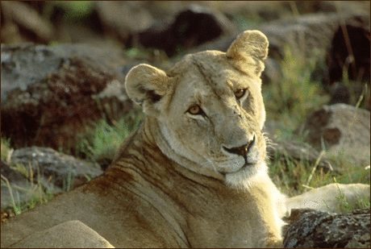  4  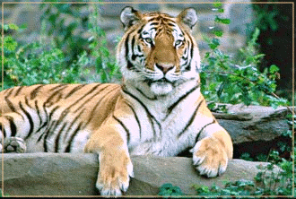  2 | 4  I live in Africa and Asia. I am a big cat. I have yellow and brown fur.  LION
2  I am a dangerous animal. I live in Asia. I am a big cat. My fur is orange and white with black lines.  TIGER |  | 5  I am an African animal. I look like a horse. I have black and white stripes on my body.  ZEBRA
3  I live in China. I am a bear. I am black and white. I like to eat bamboo.  PANDA |  | 6  I live in Australia. I have a long tail and four legs – two short and two long. I like to jump.  KANGAROO

READ AND COMPLETE THE TEXT.
CHOOSE THE WORDS FROM THE BOX.

legs | elephant | teeth | two
neck | nose | Africa | tail

There is an elephant in the picture. Elephants are large animals. They live in Africa and Asia. They have a big body. They have a very long nose (it is called a trunk). Elephants have large ears and two big teeth (called tusks). They have four legs and a tail. | 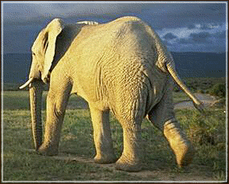  an elephant

WHAT IS YOUR FAVOURITE ANIMAL?
Write 4–6 sentences about your favourite animal.
Draw a picture of the animal.

_________________________________________
_________________________________________
_________________________________________
_________________________________________
_________________________________________
_________________________________________
_________________________________________
_________________________________________

Použité obrázky:

zebra | Zebra face Clip Art. [cit. 2010-05-06]. Dostupné pod licencí Public Domain na WWW:  <http://www.pdclipart.org/displayimage.php?album=search&cat=0&pos=1>.
žirafa | Giraffe portrait Clip Art. [cit. 2010-05-06]. Dostupné pod licencí Public Domain na WWW:  <http://www.pdclipart.org/displayimage.php?album=search&cat=0&pos=10>.
klokan | Kangaroo Clip Art. [cit. 2010-05-06]. Dostupné pod licencí Public Domain na WWW:  <http://www.pdclipart.org/displayimage.php?album=search&cat=0&pos=1>.
panda | bear Gaint Panda Clip Art. [cit. 2010-05-06]. Dostupné pod licencí Public Domain na WWW: <http://www.pdclipart.org/displayimage.php?album=search&cat=0&pos=1>.
lev | African Lion Clip Art. [cit. 2010-05-06]. Dostupné pod licencí Public Domain na WWW:  <http://www.pdclipart.org/displayimage.php?album=search&cat=0&pos=7>.
tygr | tiger Clip Art. [cit. 2010-05-06]. Dostupné pod licencí Public Domain na WWW: <http://www.pdclipart.org/displayimage.php?album=search&cat=0&pos=8>.
slon | elephant at sunset Clip Art. [cit. 2010-05-06]. Dostupné pod licencí Public Domain na WWW:  <http://www.pdclipart.org/displayimage.php?album=search&cat=0&pos=14>.

