I | HAVE | N´T | GOT | AM | CAN | DO | ING | . | WAS | A
YOU | HAVE | N´T | GOT | ARE | CAN | DO | ING | . | WERE | A
HE | HAS | N´T | GOT | IS | CAN | DOES | ING | S | WAS | A
SHE | HAS | N´T | GOT | IS | CAN | DOES | ING | S | WAS | A
IT | HAS | NOT | GOT | IS | CAN | DOES | ING | S | WAS | AN
WE | HAVE | NOT | GOT | ARE | CAN | DO | ING | ? | WERE | AN
YOU | HAVE | NOT | GOT | ARE | CAN | DO | ING | ? | WERE | AN
THEY | HAVE | NOT | GOT | ARE | CAN | DO | ING | ? | WERE | AN

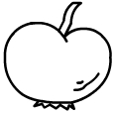 | 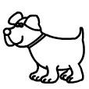 | 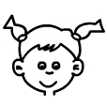 | LIKE | RIDE  A  BIKE | RED
 |  |  |  |  | BLUE
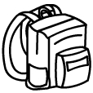 | 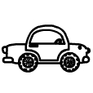 | 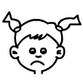 | WRITE | PLAY  THE  PIANO | BLACK
 |  |  |  |  | YELLOW
 | 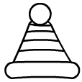 | 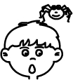 | READ | SKATE | TWO
 |  |  |  |  | THREE
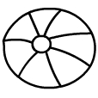 | 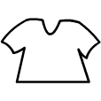 | 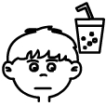 | SWIM | EAT | FOUR
 |  |  |  |  | FIVE

