
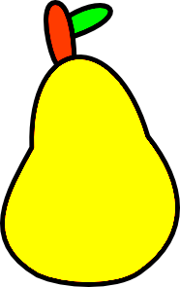


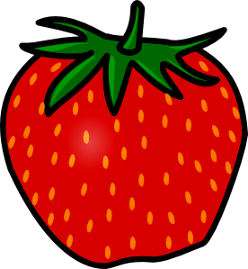


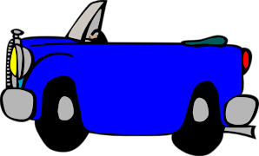
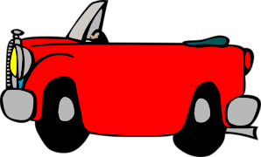
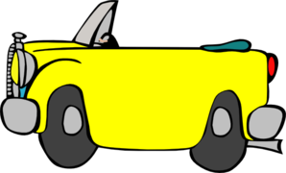
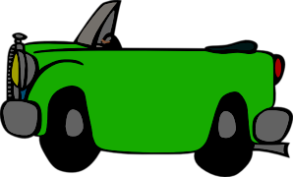















Veškerý obrazový materiál [cit. 2011-10-11]. Dostupný pod licencí Public domain na WWW:

jablíčko ................................................................... <http://www.clker.com/clipart-4010.html>
hruška ................................................................... <http://www.clker.com/clipart-28751.html>
jahoda ..................................................................... <http://www.clker.com/clipart-4002.html>
modré auto ...................................................... <http://www.clker.com/clipart-autobleu.html>
červené auto ................................................ <http://www.clker.com/clipart-autorouge2.html>
žluté auto ....................................................... <http://www.clker.com/clipart-autojaune.html>
zelené auto ....................................................... <http://www.clker.com/clipart-autovert.html>
semafor – červené světlo … <http://www.clker.com/clipart-traffic-semaphore-red-light.html>
semafor – zelené světlo .. <http://www.clker.com/clipart-traffic-semaphore-green-light.html>
semafor – žluté světlo .... <http://www.clker.com/clipart-traffic-semaphore-yellow-light.html>
semafor – silueta .............. <http://www.clker.com/clipart-traffic-semaphore-silhouette.html>
mýdlo ........................................................... <http://www.clker.com/clipart-bar-of-soap.html>
ručník .............................................................<http://www.clker.com/clipart-bath-towel.html>
penguin ................................................ <http://www.clker.com/clipart-bathing-penguin.html>
zubní kartáček ..........................................................<http://www.clker.com/clipart-2905.html>

