Pracovní list č. 1a Přečti text, doplň „family tree“ a zapiš do tabulky správná jména.

This is my family. My mum is Lana. She is 35 years old. She´s got blond hair. My dad is Kevin, he’s got short brown hair and glasses. My brother is Jason, he’s six years old. Oh, I am Mike. I am eleven. My dad has got a sister. She’s Petra. My grandma is Fiona, she is 78. My granddad is Alex. He’s 81 years old.

+

+

MUM | DAD | ME | MY GRANDMA | MY GRANDAD | MY BROTHER | MY AUNT

Pracovní list č. 1b Přečti si údaje v tabulce, zaznamenej je do “family tree”, nakresli obrázky dle popisu.

+

+ +

MY MUM | MY DAD | MY AUNT | ME | MY UNCLE | MY GRANDMA | MY GRANDAD
Helen | Paul | Melissa | Sonja | Jason | Danna | Frank
31 | 36 | 40 | twelve | 41 | 81 | 81
blond, long hair | glasses, short black hair | short blond hair | long brown hair | blue eyes, glasses | green eyes, glasses | brown hair, glasses

Pracovní list č. 1c Úkol pro tebe – podle “family tree” vytvoř věty o rodině z nápovědy.

+ +

MY GRANDMA | I´m Paula. | Alexander | MY AUNT | Alexis | Green eyes
Brown hair | MY MUM | I´m ten. | ME | MY SISTER | She´s eleven.
MY UNCLE | Carol | Fabrizio | Blue eyes | Peter | glasses
glasses | She´s Helen. | Short blond hair | MY DAD | Long black hair | MY GRANDAD

Pracovní list č. 2 Slož slova podle obrázků a napiš je.
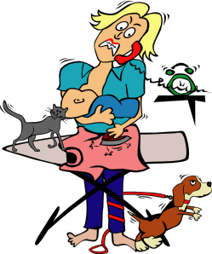 M/L/M/U/K/ ___________

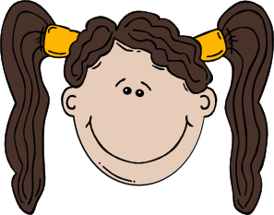 O/S/Q/P/I/S/A/T/R/E/ ___________
 A/F/K/M/Y/L/I/F/ ___________
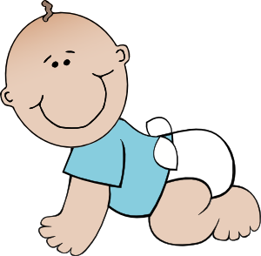 A/B/B/E/I/Y ___________
 B/S/R/A/O/T/H/W/E/R ___________
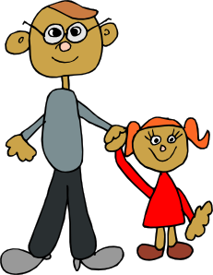 G/A/D/B/M/D/P/O ___________
Pracovní list č. 3 Ke kterému obrázku se hodí následující věty? Doplň písmena.

 | 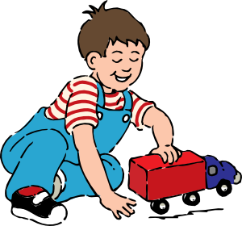 | 
 |  | 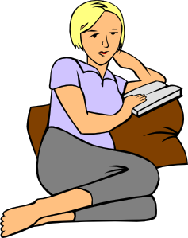

A/ This is my aunt Alison. She’s got blond hair.
B/ This is my dad Richard and my little sister Danna. Danna is two years old.
C/ This is my brother Ian. He’s twelve years old. He’s got glasses.
D/ This is my family.
E/ This is my mum Carol and my dad Richard.
F/ My mum Carol has got blond hair. She’s got a dog and a cat.
G/ This is me. My name is Patricia and I am ten. I’ve got long hair.
H/ My brother Jack is five. He’s got short brown hair.
Pracovní list č. 4 Doplň věty podle tabulky, poslední řádek doplň sám/sama. Napiš věty.

NAME | BROTHER/S | SISTER/S
JACK | 2 | 0
PHIL | 0 | 1
JANE | 1 | 1
KATE | 0 | 1

I have got _____ sister/s. Jane has got one _____ and one _____. Jack hasn´t got a _____, but he has got _____ brothers. Phil and Jane have got one _____. Kate hasn´t got a _____.

Přečti si věty a doplň údaje do tabulky.
NAME | BROTHER/S | SISTER/S
KEN
DAVID
MATT
ANNIE

My name is Ken. I´ve got two brothers and one sister.
Hello, my name is Annie. I haven´t got a brother or a sister.
My name’s David. I’ve got three little sisters.
Hello, I am Matt. I have got one sister, but I haven’t got a brother.
Pracovní list č. 5a Čtení pro dva žáky A

A/ Čti spolužákovi. (Bude-li potřeba, opakuj čtení vícekrát.)
Hello. This is my family. My name is Susan Novack. I am twelve years old and I am from London. I´ve got two brothers and a little sister. My sister is Kelly and she is five. Her favourite colour is yellow. My brothers are Jack and David. Jack is seven and David is nine. They´ve got fish at home. My mum is Paula. She is very clever. She´s got long brown hair and blue eyes. My dad is Martin. He is blond with short hair. We have a dog at home.

B/ Poslouchej a doplňuj údaje do tabulky. (Bude-li potřeba, vyžádej si vícero čtení textu, poté vyprávěj dle tabulky.)

MY DAD | ME | MY SISTER | MY MUM | MY BROTHERS | ANIMALS AT HOME

Pracovní list č. 5b Čtení pro dva žáky A

B/ Čti spolužákovi. (Bude-li potřeba, opakuj čtení vícekrát, poté nakresli postavy, popiš vlastními slovy.)
Hello. This is my family. My name is Jeremy Fulton. I am fourteen years old and I am from Oxford. I´ve got one brother and a little sister. My sister is Pam and she is one. She is a baby. My brother is Peter. He is eight. We´ve got a hamster at home. My mum is Doreen. She is very clever. She´s got long black hair and green eyes. My dad is Alec. He is blond with short hair. We have a dog and a cat at home.

A/ Poslouchej a doplňuj údaje do tabulky. (Bude-li potřeba, vyžádej si vícero čtení textu, poté vyprávěj dle tabulky.)

MY DAD | ME | MY MUM | MY BROTHER | ANIMALS AT HOME | MY SISTER

