My friends – pracovní list 1
My name is ………………………………………………………………………

About me:
Animal:
Have you got a dog? Yes, I have. No, I haven´t.
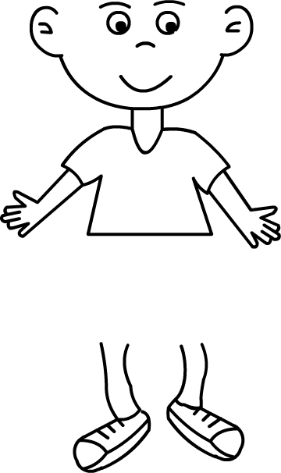
Musical instrument:
Can you play the piano? Yes, I can. No, I can´t.
Free time:
Do you watch TV in your free time? Yes, I do. No, I don´t.
Like:
Do you like apples? Yes, I do. No, I don´t.

There are 6 friends: Mary, George, Dick, John, Peggy, Sue.

Animal: parrot, mouse, fish, dog, rabbit
Musical instrument: piano, drum, violin, guitar, flute
Free time: ride a horse, read a book, play basketball, watch TV, write e-mails
Like: apple, oranges, ice-cream, banana, chips
 | Have you got … ? | Can you play  the … ? | Do you … in your free time? | Do you like … ?
 | Animal | Musical instrument | Free time | Like
Mary
George
Dick
John
Peggy
Sue

