Spoj obrázek s fotografií
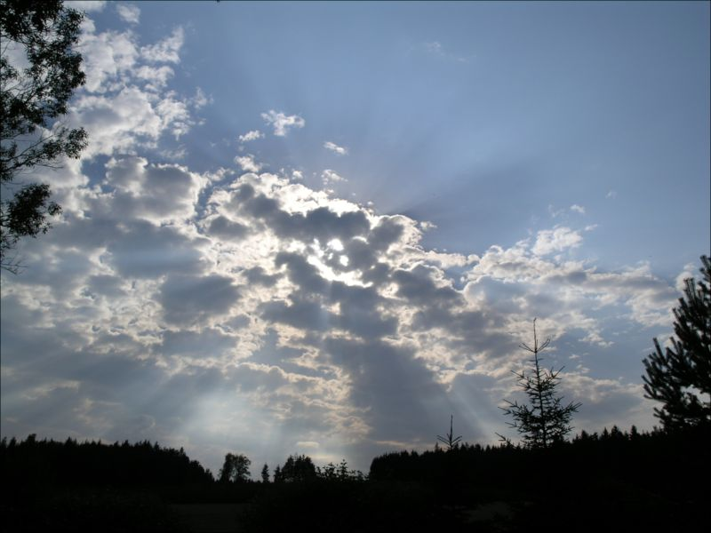
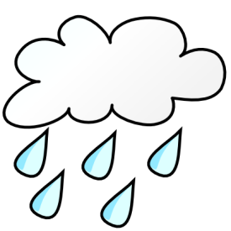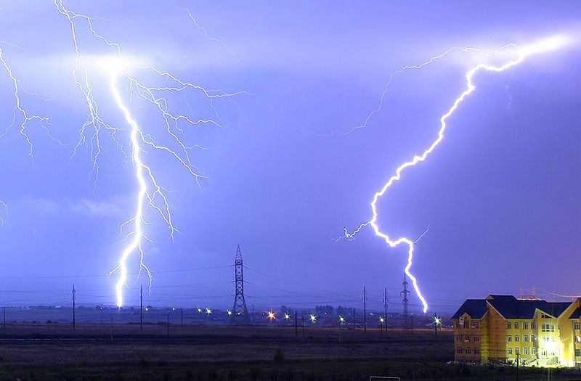
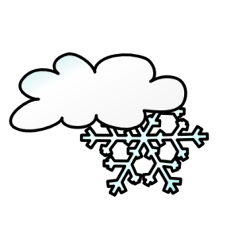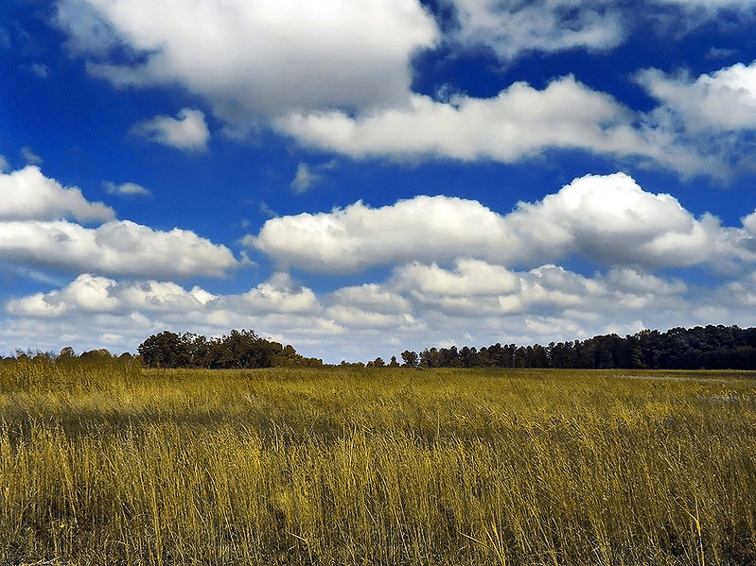
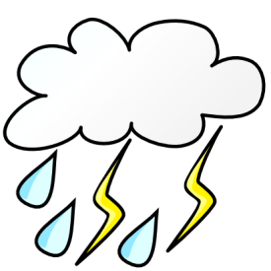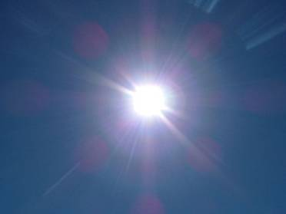
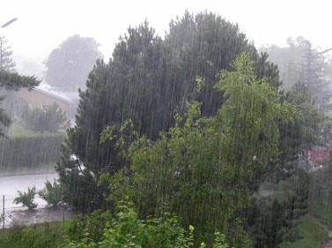
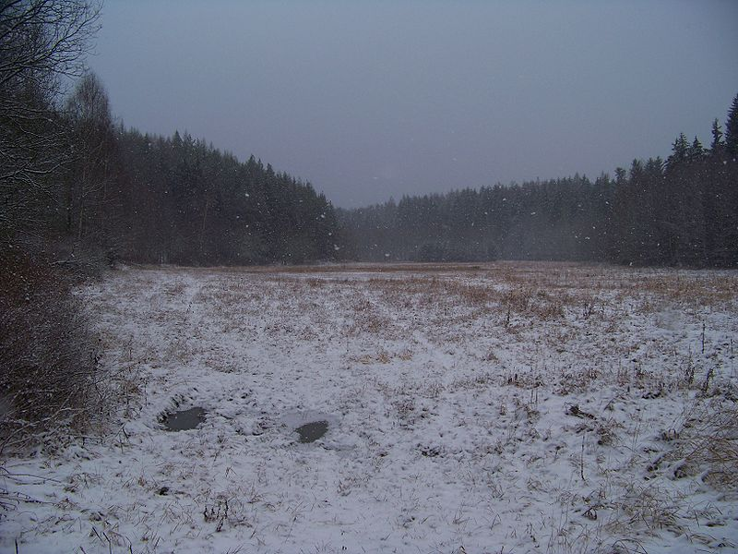

Všechny uveřejněné odkazy [cit. 2009-27-01]. Dostupné pod licencí Public Domain – na http://www.public-domain-photos.com/.
http://www.public-domain-photos.com/free-cliparts/signs_and_symbols/weather/cloudy01-7279.htm
http://www.public-domain-photos.com/free-cliparts/signs_and_symbols/weather/rain-7298.htm
http://www.public-domain-photos.com/free-cliparts/signs_and_symbols/weather/snowstorm-7300.htm
http://www.public-domain-photos.com/free-cliparts/signs_and_symbols/weather/storm-7302.htm
http://www.public-domain-photos.com/free-cliparts/signs_and_symbols/weather/sun01-7303.htm
http://www.public-domain-photos.com/free-cliparts/signs_and_symbols/weather/w_cloud-7308.htm

Všechny uveřejněné odkazy [cit. 2009-27-01]. Dostupné pod licencí Creative Commons – na http://www.wikipedia.org/.
http://commons.wikimedia.org/wiki/File:Heralec-mraky.jpg
http://commons.wikimedia.org/wiki/File:Lightning_over_Oradea_Romania_zoom.jpg
http://cs.wikipedia.org/wiki/Soubor:GoldenMedows.jpg
http://en.wikipedia.org/wiki/File:The_sun1.jpg
http://cs.wikipedia.org/wiki/Soubor:22_Regen_ubt.jpeg
http://commons.wikimedia.org/wiki/File:Prvn%C3%AD_luh.jpg

