Meal Preparation
- Cooking and baking (Tučné výrazy přeložte)
Good chefs say that food tastes better when cooked on a gas stove, rather than on electric one. Though they are both better than using a microwave oven.
I am still learning to how to cook. I use a cookbook to explain all of the directions needed to make something. Some of the recipes are difficult and require tools, for example a food processor. A food processor is a machine that cuts food into small pieces of very quickly.
Measuring spoons and measuring cups are very helpful when you are baking. You need to be precise with the ratios of each ingredient when you bake and these help you a lot. If you are baking a cake it helps if you cover the cake tin in cooking spray or butter before pouring in the cake mix. This way after the cake is baked and cooled it will come out of the cake tin easily. Be careful when taking a baking tray out of the oven. Be sure to use an oven mitt or oven gloves so that you don't burn your hands.
bake – cookbook –
baked – cooled –
burn – cut –
cake – pouring –
cook – recipes –
cooked – taste –

- Cooking Instructions (Doplňte následující výrazy k definicím)
- add
- bake
- barbecue
- beat
- boil
- break
- broil
- carve
- chop
- combine
- cook
- crush
- cut
- fry
- grate
- grease
- grill
- knead
- mix
- measure
- microwave
- open
- peel
- pour
- put
- roast
- sauté
- scramble
- slice
- steam
- stir
32- stir fry
- wash
- weigh

______: To cut into small pieces, generally used with vegetables.
______: To separate or divide by using a knife.
______: To cook in an oven by using heat.
______: To heat water until little bubbles are formed.
______: To cook meat or vegetables on a rack with an extremely high temperature.
______: To cut meat into slices.
______: To prepare food by heating it, so the food is not raw.
______: To cook foods (primarily meat) on a grill by using fire or hot coals.
______: To put two or more things together.
______: To separate into smaller parts by force.
______: To mix quickly and continually, commonly used with eggs.
______: To put ingredients together; to put one ingredient with the others.
______: To divide into small parts by rubbing on a serrated surface, usually used with cheese.
______: To mix liquid ingredients by moving a spoon around in a circular motion.
______: To cook small pieces of food by moving it quickly in hot oil
______: To cook by placing the food above boiling water. Steam is the hot gas that
______: To immerse food in water and make sure it becomes clean.
______: To cause to separate or flatten by extreme force, often used with garlic.
______: To heat up food within a microwave oven.
______: To press and stretch dough, usually used with making bread.
______: To mix the white and yellow parts of eggs together while cooking them in a pan.
______: To coat with oil or butter.
______: To cook by putting the food on a grill; similar to barbecue.
______: To remove the top from a can or jar.
______: To combine two or more things using a spoon, a spatula, or an electric mixer.
______: To transfer liquid from one container to another.
______: To quickly fry food by placing it in hot oil in a frying pan.
______: To take off the skin of fruits or vegetables.
______: To cook by putting the food into extremely hot oil.
______: To cook in the oven or over a fire.
______: To place something in a particular position or location.
______: To measure the weight (grams or pounds) or something
______: To cut into thin, wide portions.
______: To obtain an exact quantity.

- Crossword
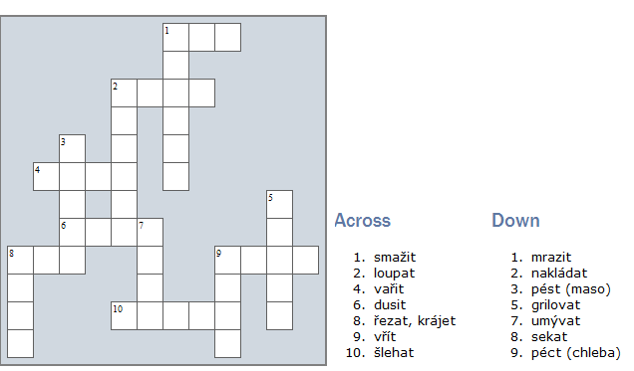

Meal Preparation – řešení
- Cooking and baking (Tučné výrazy přeložte)
bake – péct cookbook – kuchařka (kniha)
baked – pečený cooled – chlazený, vychladlý
burn – spálit cut – řezat, krájet
cake – koláč, dort pouring – nalévání
cook – vařit recipes – recepty
cooked – uvařený, vařený taste – chuť, chutnat

- Cooking Instructions (Doplňte následující výrazy k definicím)
1 | : To put ingredients together; to put one ingredient with the others.
2 | : To cook in an oven by using heat.
3 | : To cook foods (primarily meat) on a grill by using fire or hot coals.
4 | : To mix quickly and continually, commonly used with eggs.
5 | : To heat water until little bubbles are formed.
6 | : To separate into smaller parts by force.
7 | : To cook meat or vegetables on a rack with an extremely high temperature.
8 | : To cut meat into slices.
9 | : To cut into small pieces, generally used with vegetables.
10 | : To put two or more things together.
11 | : To prepare food by heating it, so the food is not raw.
12 | : To cause to separate or flatten by extreme force, often used with garlic.
13 | : To separate or divide by using a knife.
14 | : To cook by putting the food into extremely hot oil.
15 | : To divide into small parts by rubbing on a serrated surface, usually used with cheese.
16 | : To coat with oil or butter.
17 | : To cook by putting the food on a grill; similar to barbecue.
18 | : To press and stretch dough, usually used with making bread.
19 | : To combine two or more things using a spoon, a spatula, or an electric mixer.
20 | : To obtain an exact quantity.
21 | : To heat up food within a microwave oven.
22 | : To remove the top from a can or jar.
23 | : To take off the skin of fruits or vegetables.
24 | : To transfer liquid from one container to another.
25 | : To place something in a particular position or location.
26 | : To cook in the oven or over a fire.
27 | : To quickly fry food by placing it in hot oil in a frying pan.
28 | : To mix the white and yellow parts of eggs together while cooking them in a pan.
29 | : To cut into thin, wide portions.
30 | : To cook by placing the food above boiling water. Steam is the hot gas that
31 | : To mix liquid ingredients by moving a spoon around in a circular motion.
32 | : To cook small pieces of food by moving it quickly in hot oil
33 | : To immerse food in water and make sure it becomes clean.
34 | : To measure the weight (grams or pounds) or something

- Crossword
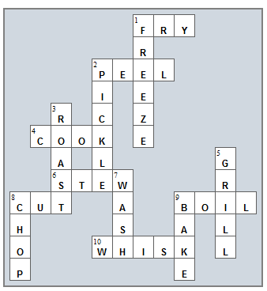
Použité zdroje a literatura:
The Kitchen. English Vocabulary [online]. 2003-2012 [cit. 2012-11-12]. Dostupné
z: http://www.vocabulary.cl/Intermediate/Kitchen.htm
Kitchen Appliances. The English Space [online]. 2008-2012 [cit. 2012-11-12]. Dostupné z: http://www.theenglishspace.com/vocabulary/house/kitchen-appliances.html
Eclipse Crossword. Eclipse Crossword [online]. 1999-2012 [cit. 2012-11-13]. Dostupné z: http://www.eclipsecrossword.com/

