READ THE PICTURES AND SAY WHAT IS:

- IN THE UPPER–LEFT
- IN THE LOWER–RIGHT
- IN THE LOWER–LEFT
- IN THE UPPER–RIGHT
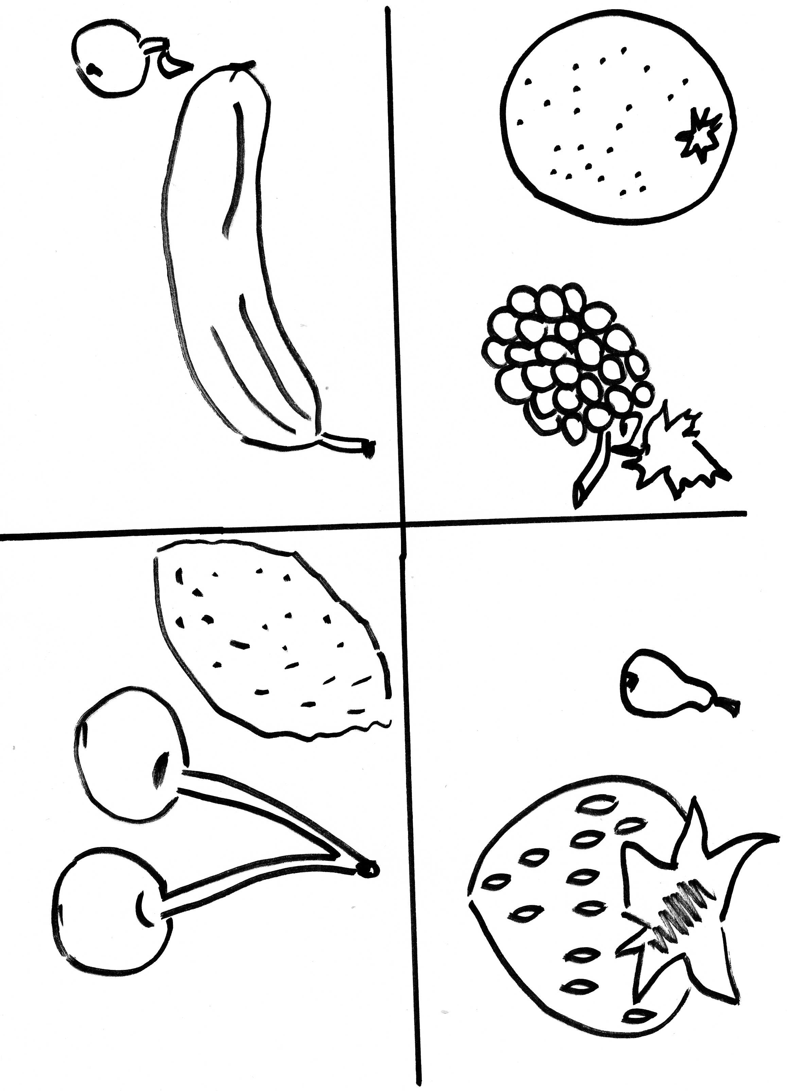
Zdroj obrázků: autorka materiálu

