Podívej se na obrázky a zvířátka vlevo spoj čarou s obrázky vpravo, které k nim patří.
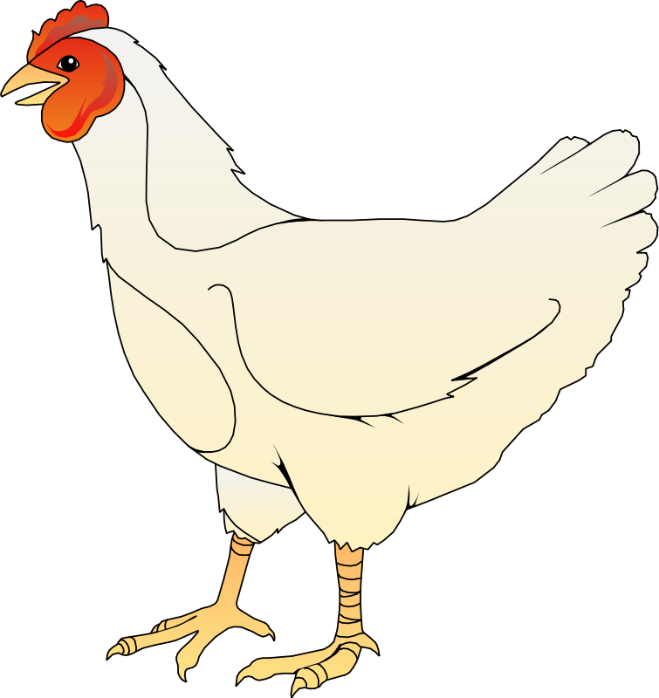
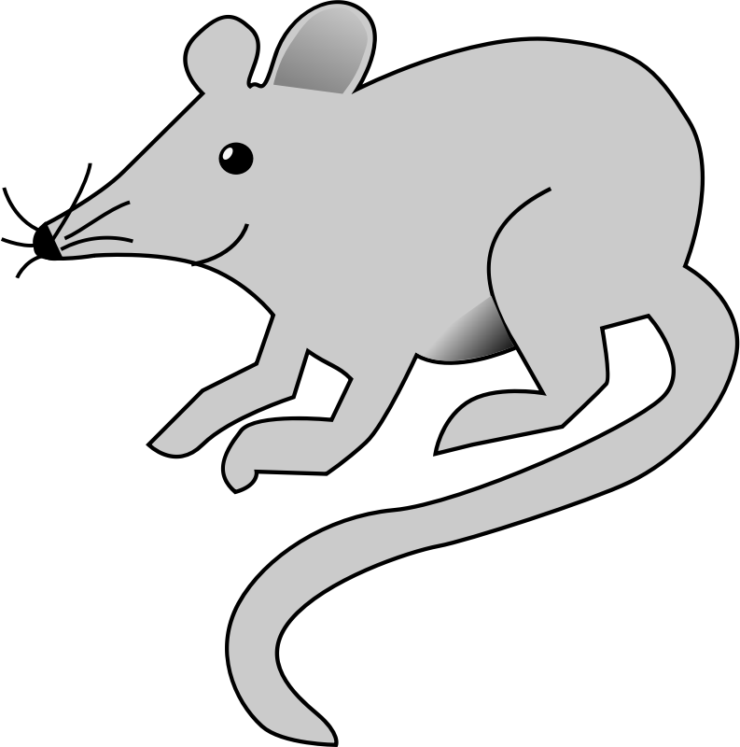
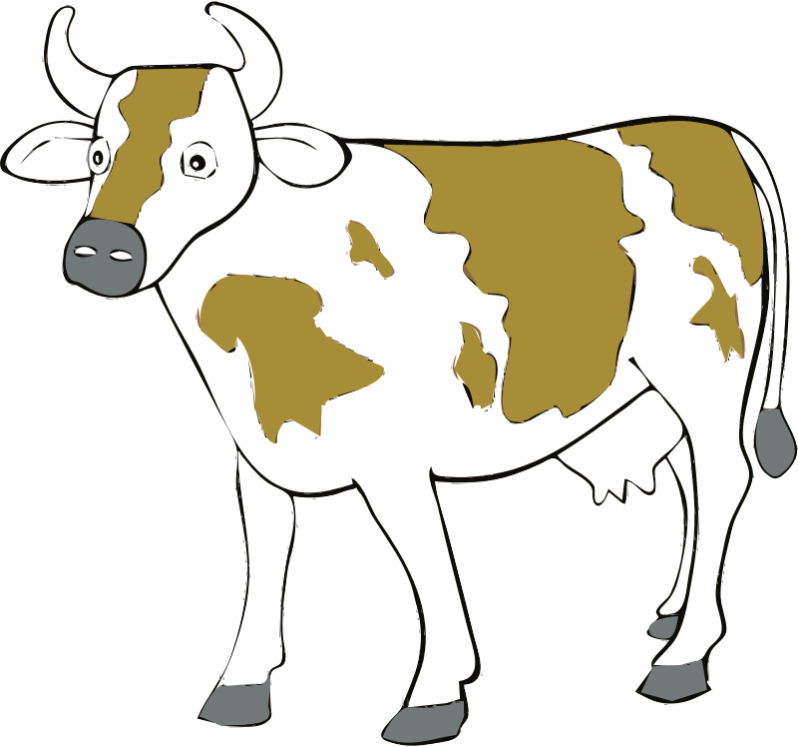

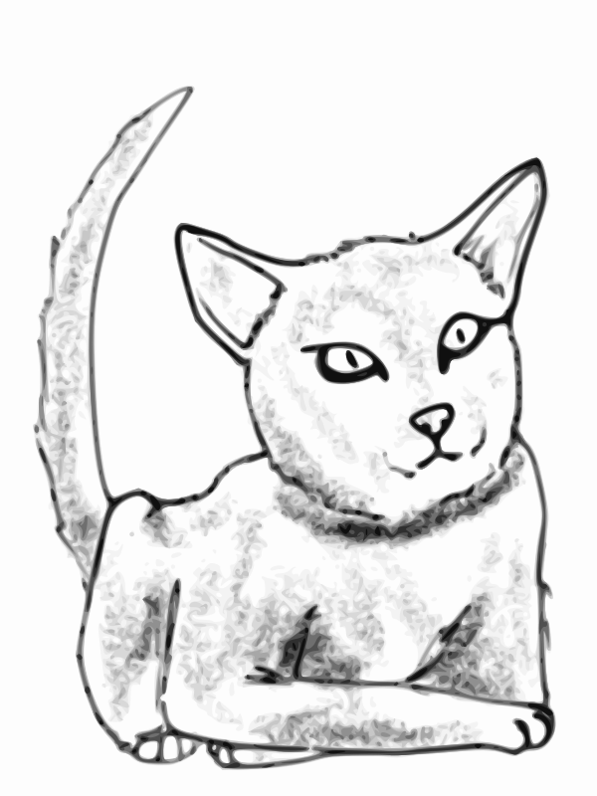


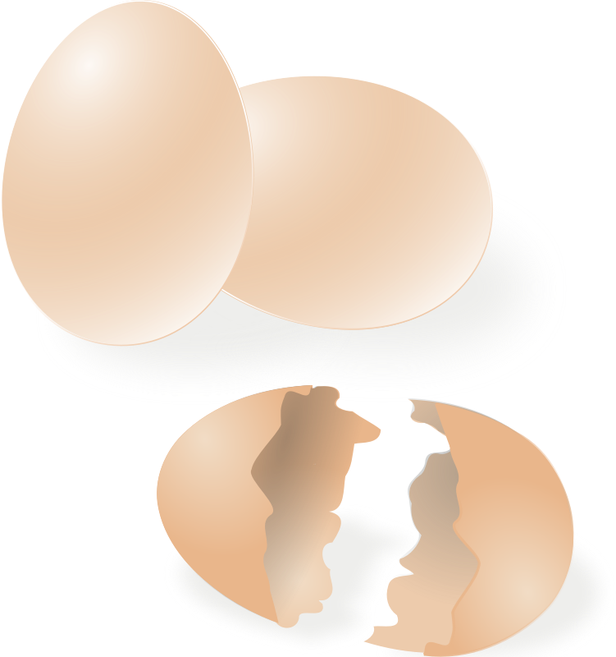

[online].[cit. 2014-12-26]. Dostupný pod licencí Public domain na WWW:
<https://openclipart.org/detail/181958/cat-by-child_of_light-181958>
<https://openclipart.org/detail/20158/eggs-by-rg1024-20158>
<https://openclipart.org/detail/193718/milk-carton-by-onsemeliot>
<https://openclipart.org/detail/8498/dog-(simple-drawing)-by-gerald_g-8498>
<https://openclipart.org/detail/196043/-15-by-rdevries-196043>
<https://openclipart.org/detail/175283/ayam-betina-by-andinuryadin-175283>
<https://openclipart.org/detail/194576/cow-by-BadaBing-194576>
<https://openclipart.org/detail/2971/mouse-by-da5id1>

Na tomto obrázku spoj čarou zvířátka s jejich správnými domečky.
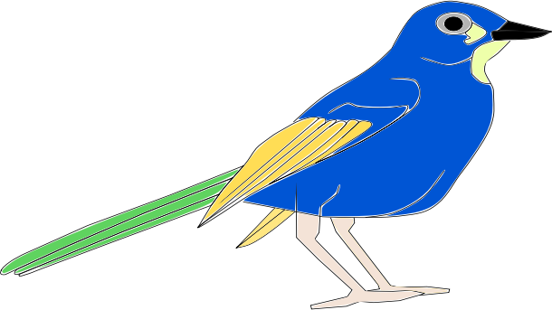

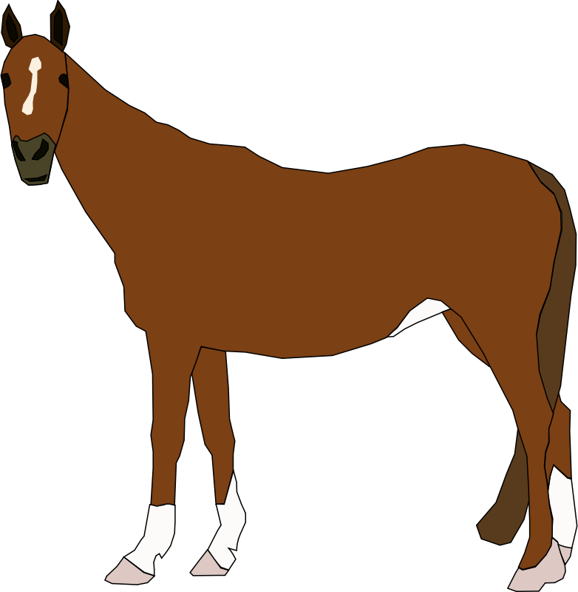
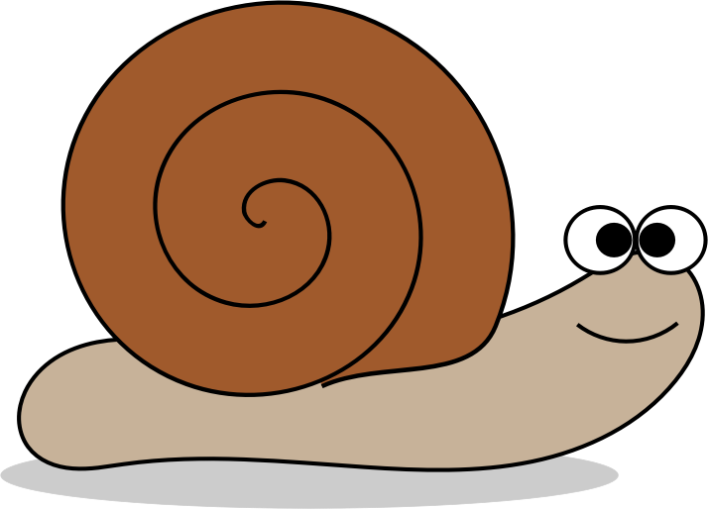
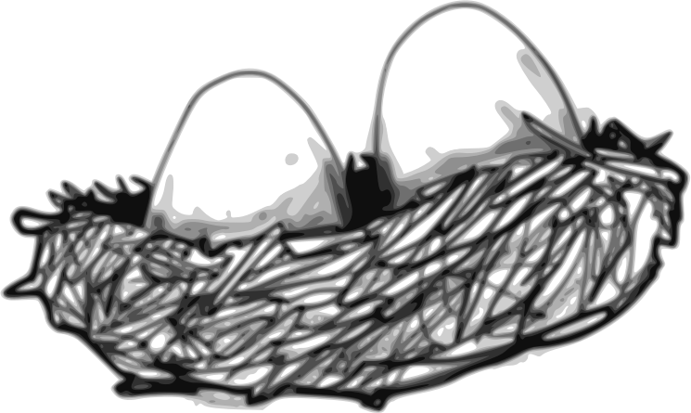




[online].[cit. 2014-12-26]. Dostupný pod licencí Public domain na WWW:
<https://openclipart.org/detail/145351/pajaro-by-sebas>
<https://openclipart.org/detail/177776/birds-nest-by-child_of_light-177776>
<https://openclipart.org/detail/172797/bee-by-jamiely-172797>
<https://openclipart.org/detail/3866/apiary-by-doctormo>
<https://openclipart.org/detail/201617/snail-by-agomjo-201617>
<https://openclipart.org/detail/192918/snail-shell-by-scout-192918>
<https://openclipart.org/detail/2691/horse-by-machovka>
<https://openclipart.org/detail/181745/stall-by-rdevries-181745>
Spoj dospělého jedince na levé straně s jeho mládětem vpravo.

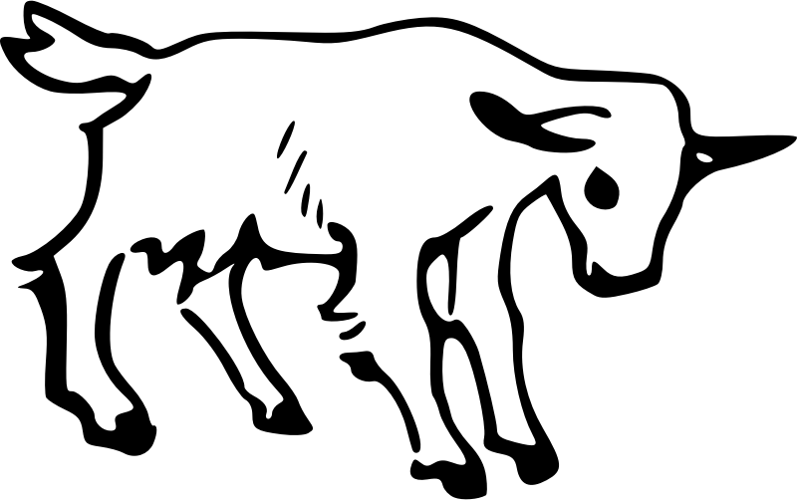

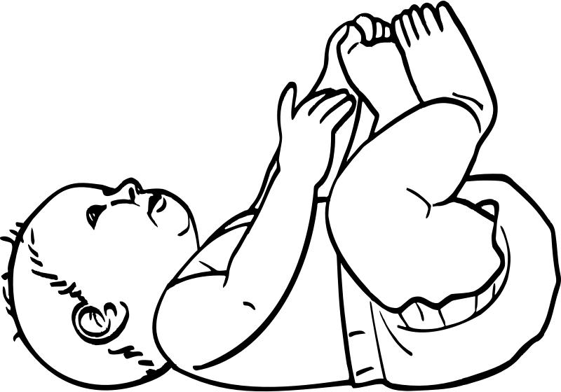


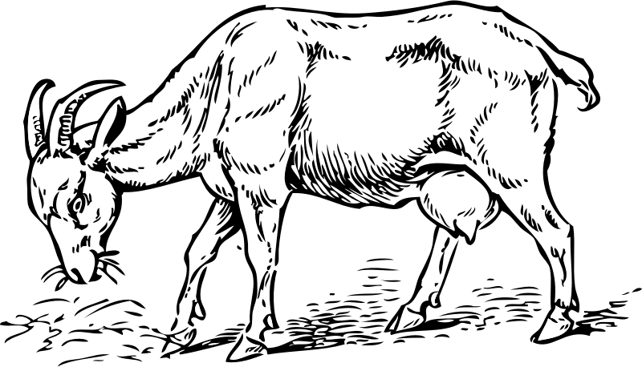

[online].[cit. 2014-12-26]. Dostupný pod licencí Public domain na WWW:
<https://openclipart.org/detail/173498/retro-woman-2-by-tikigiki-173498>
<https://openclipart.org/detail/175283/ayam-betina-by-andinuryadin-175283>
<https://openclipart.org/detail/1452/goat-by-johnny_automatic>
<https://openclipart.org/detail/16228/goat-by-gerald_g>
<https://openclipart.org/detail/23375/the-pig-by-irinuca>
<https://openclipart.org/detail/175283/ayam-betina-by-andinuryadin-175283>
<https://openclipart.org/detail/3503/-by--3503>
<https://openclipart.org/detail/207926/Inhabitants-Piglet-by-glitch>

