Worksheet 1 - WORD UNSCRAMBLE

Scramble the letters and write the words correctly:

Example: kobo = book

1. Clothes:

sjaen |   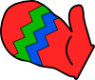
tekcaj | 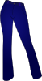
ite
wreseta | 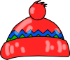
pca
tsikr | 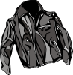
tsev
sloevg |   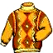
rstih
ghitst

2. Colors:
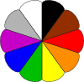

dre
lube
wloely
reneg
hitew
genaro
lkbac
regy
telovi
nrowb

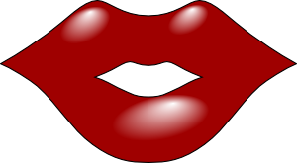
3. Body:

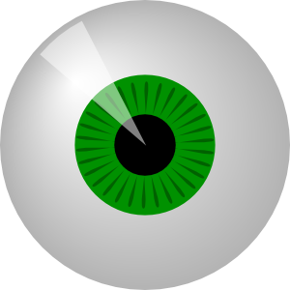
eey
dahe
are
seno
ouhtm
caef
gle
dahn
redsoushl
tfoo

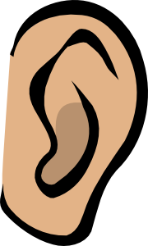

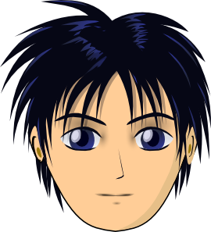

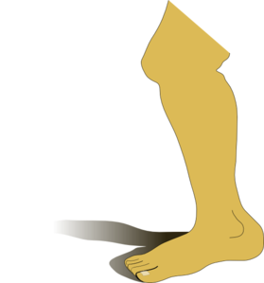

Všechny uveřejněné odkazy [cit. 2012-02-20]. Dostupné pod licencí Public domain na WWW:

<http://www.clker.com/clipart-40424.html> kalhoty
<http://www.clker.com/clipart-26767.html> bunda
<http://www.clker.com/clipart-28045.html> sukně
<http://www.clker.com/clipart-4223.html> košile
<http://www.clker.com/clipart-4229.html> rukavice
<http://www.clker.com/clipart-4230.html> čepice
<http://www.clker.com/clipart-26813.html> barvy
<http://www.pdclipart.org/displayimage.php?album=33&pos=135> svetr
<http://www.clker.com/clipart-2586.html> ústa
<http://www.clker.com/clipart-11409.html> oko
<http://www.clker.com/clipart-4337.html> ucho
<http://www.clker.com/clipart-2313.html> obličej a vlasy
<http://www.clker.com/clipart-leg-1.html> noha

