COMPLETE THE CROSSWORD.

1 | 2 | 3
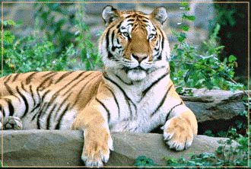 | 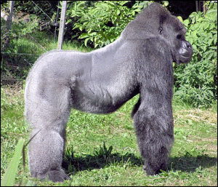 | 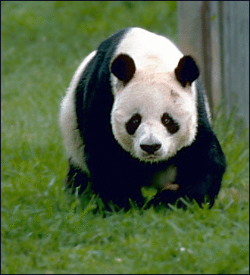
4 | 5 | 6
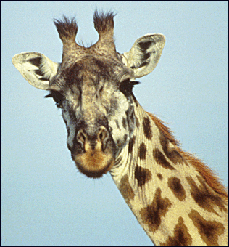 | 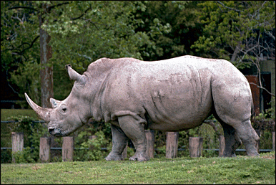 | 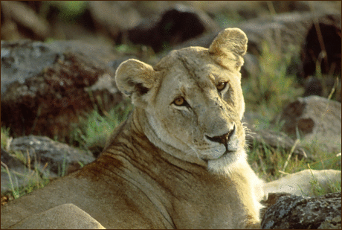
7 | 8 | 9
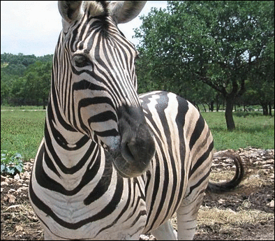 | 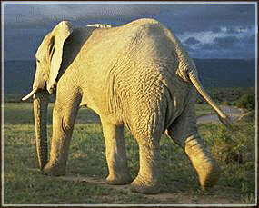 | 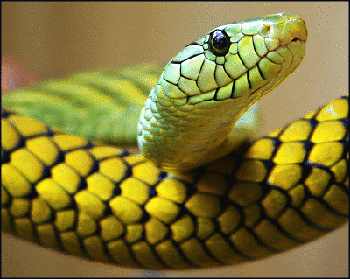

W
M
1
2
3
4
5
6
7
8
9
Použité obrázky:

tygr | tiger Clip Art. [cit. 2010-05-06]. Dostupné pod licencí Public Domain na WWW:  <http://www.pdclipart.org/displayimage.php?album=search&cat=0&pos=8>.
gorila | lowland gorilla Clip Art. [cit. 2010-05-06]. Dostupné pod licencí Public Domain na WWW:  <http://www.pdclipart.org/displayimage.php?album=search&cat=0&pos=3>.
panda | bear Gaint Panda Clip Art. [cit. 2010-05-06]. Dostupné pod licencí Public Domain na WWW:  <http://www.pdclipart.org/displayimage.php?album=search&cat=0&pos=1>.
žirafa | Giraffe portrait Clip Art. [cit. 2010-05-06]. Dostupné pod licencí Public Domain na WWW:  <http://www.pdclipart.org/displayimage.php?album=search&cat=0&pos=10>.
nosorožec | rhinoceros White Rhino Clip Art. [cit. 2010-05-06]. Dostupné pod licencí Public Domain na WWW:  <http://www.pdclipart.org/displayimage.php?album=search&cat=0&pos=7>.
lev | African Lion Clip Art. [cit. 2010-05-06]. Dostupné pod licencí Public Domain na WWW:  <http://www.pdclipart.org/displayimage.php?album=search&cat=0&pos=7>.
zebra | Zebra face Clip Art. [cit. 2010-05-06]. Dostupné pod licencí Public Domain na WWW:  <http://www.pdclipart.org/displayimage.php?album=search&cat=0&pos=1>.
slon | elephant at sunset Clip Art. [cit. 2010-05-06]. Dostupné pod licencí Public Domain na WWW:  <http://www.pdclipart.org/displayimage.php?album=search&cat=0&pos=14>.
had | snake 1 Clip Art. [cit. 2010-05-06]. Dostupné pod licencí Public Domain na WWW:  <http://www.pdclipart.org/displayimage.php?album=search&cat=0&pos=16>.

