Name | 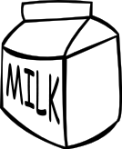 |  |  |  | 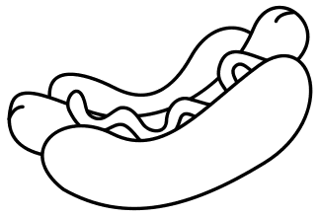

Name

Name

Zdroje [cit. 2010-01-09]. Dostupné pod licencí Public Domain na www:
mléko: <http://www.pdclipart.org/displayimage.php?album=43&pos=288>
zmrzlina: <http://www.pdclipart.org/displayimage.php?album=43&pos=318>
jablko: <http://www.pdclipart.org/displayimage.php?album=42&pos=21>
chickenburger: <http://www.pdclipart.org/displayimage.php?album=42&pos=278>
hotdog: <http://www.pdclipart.org/displayimage.php?album=43&pos=153>

