FARM ANIMALS – THE PRODUCTS
Farm animals are very useful, they produce different things.
Look at the pictures and write the names of the products for each animal.
Use the words from the box. You can use the words more than once.

butter | cheese | eggs | feathers (e.g. for stuffing pillows)
skin (e.g. for bags) | meat | milk | wool

EXAMPLES
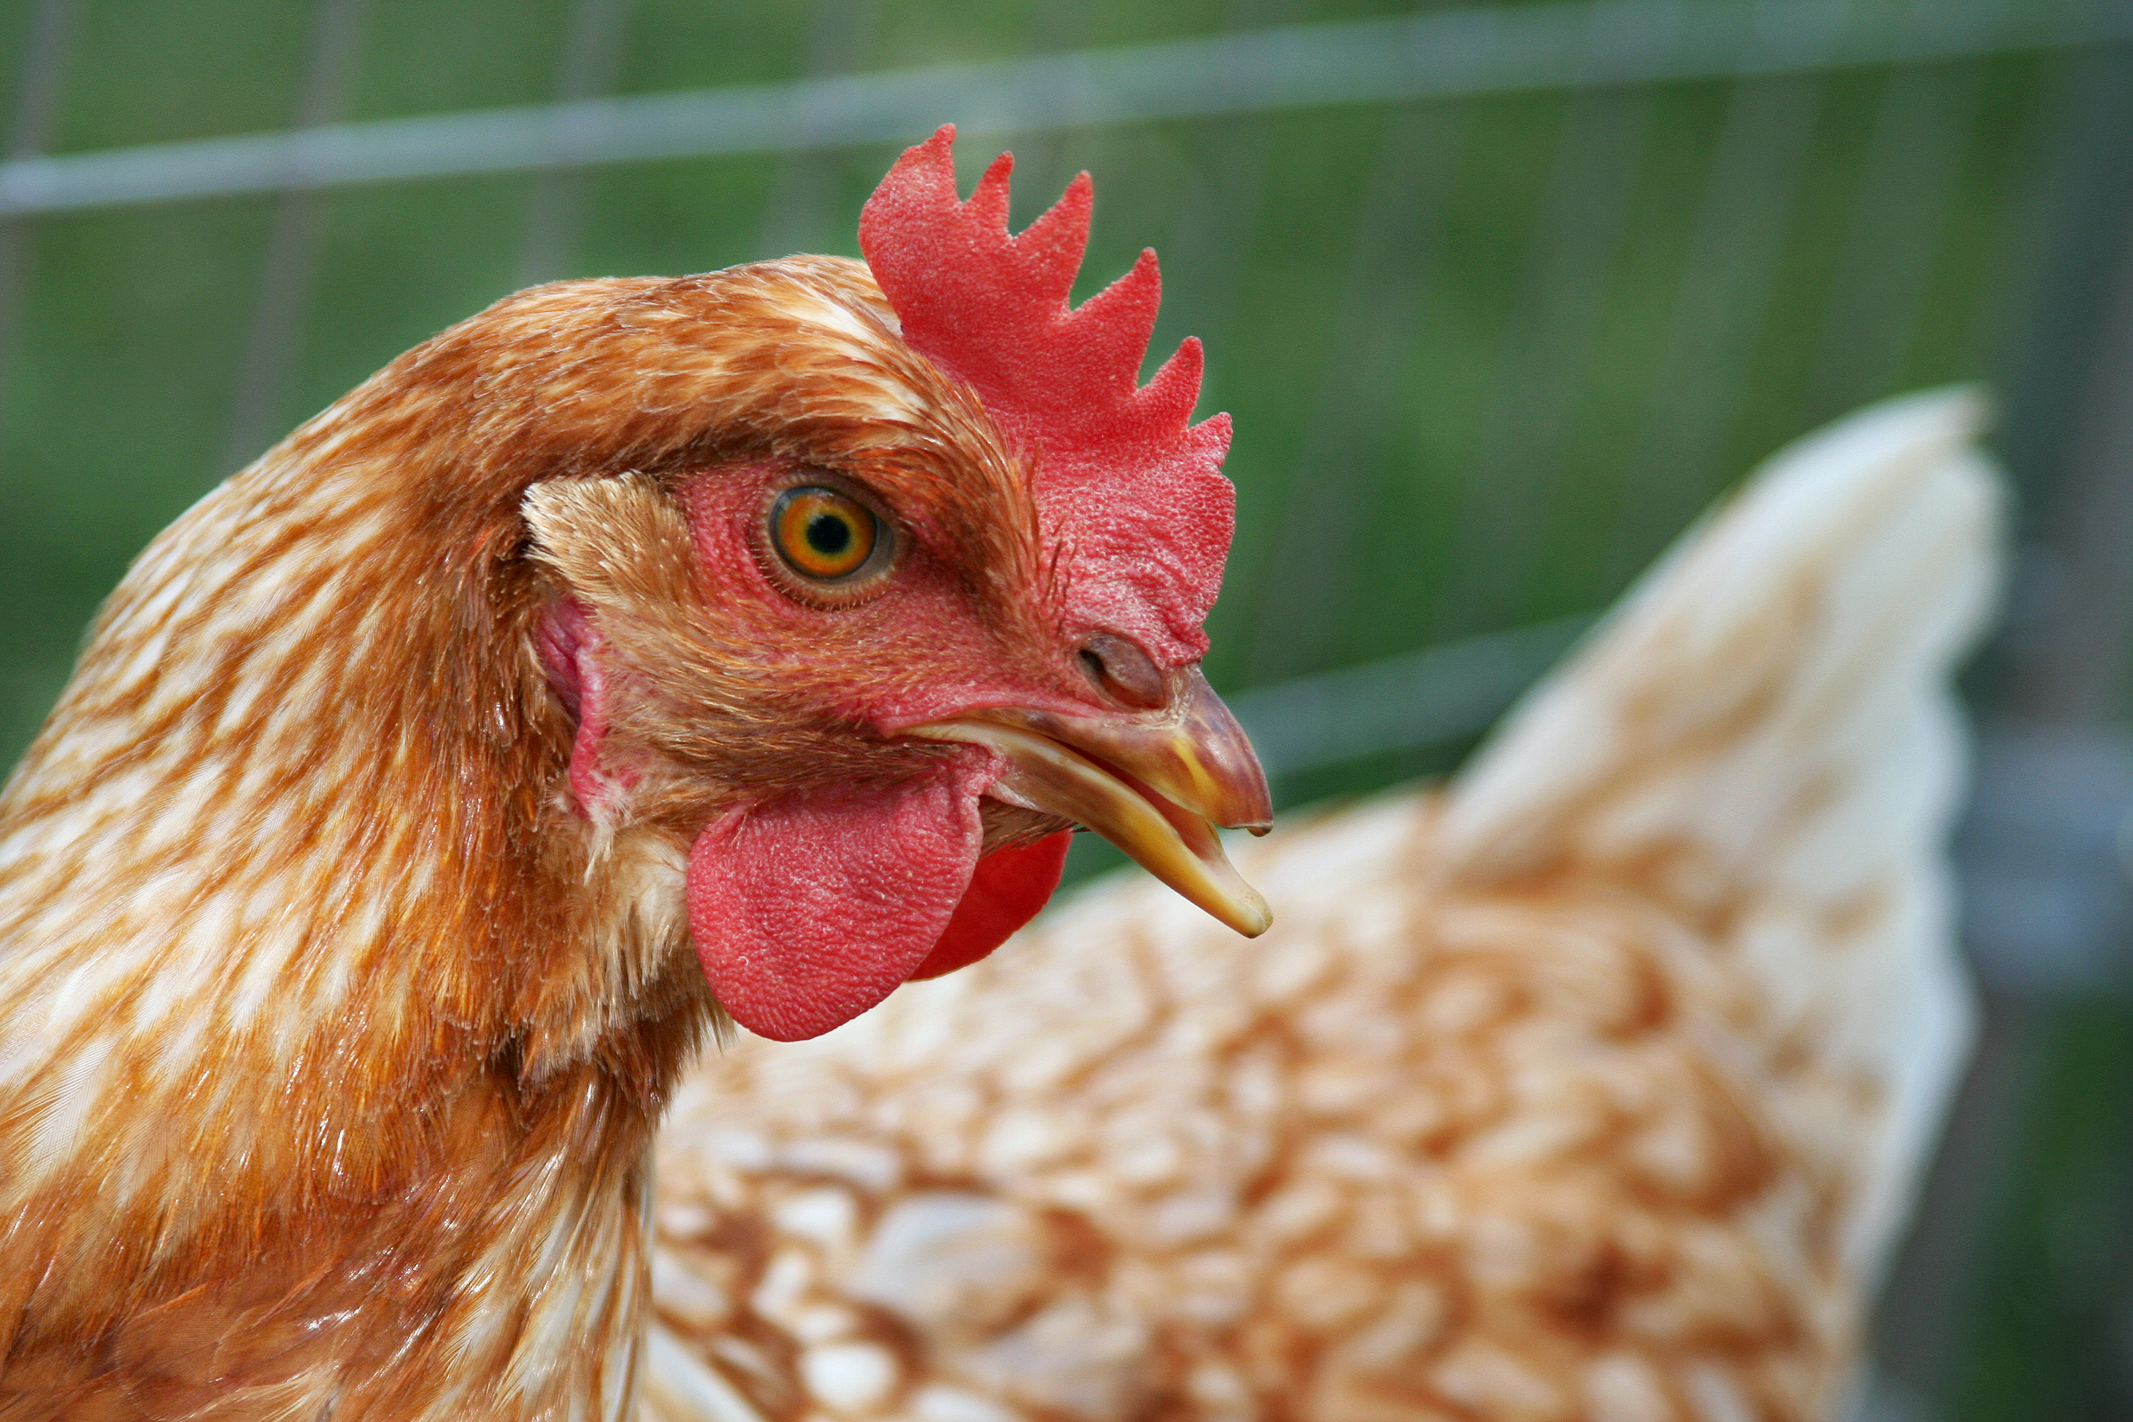 | 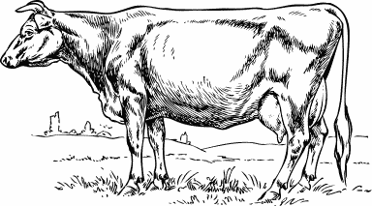 | 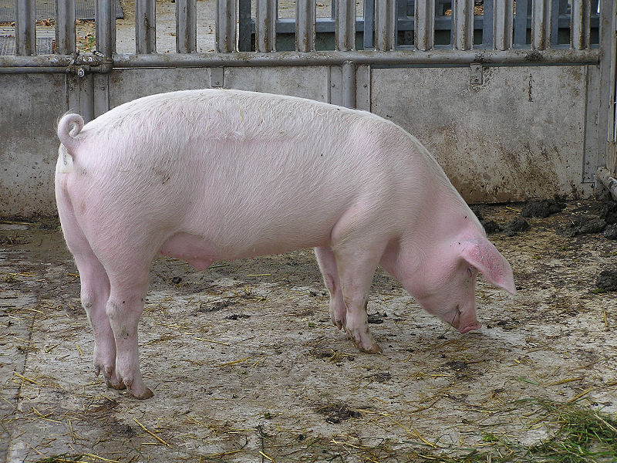
eggs  meat (chicken) | meat (beef)  milk  butter  cheese | meat (pork)  skin
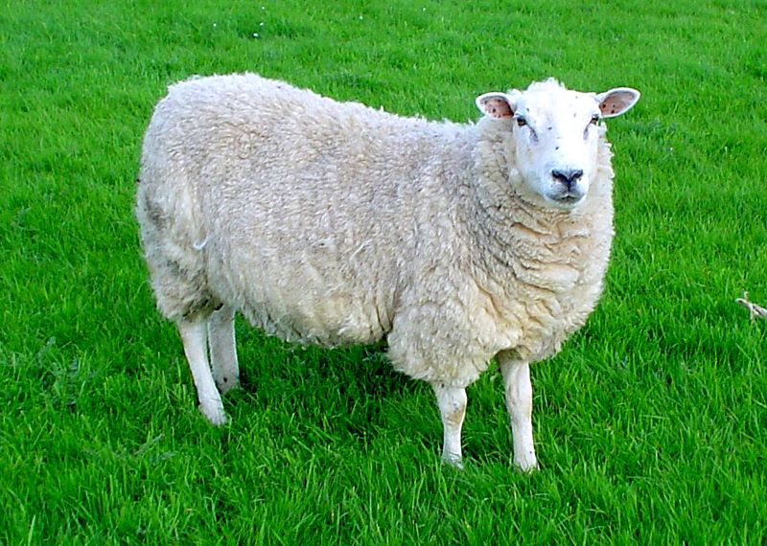 | 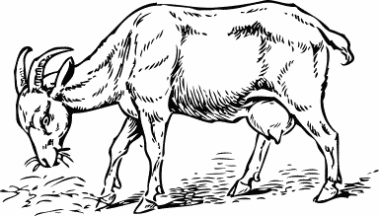 | 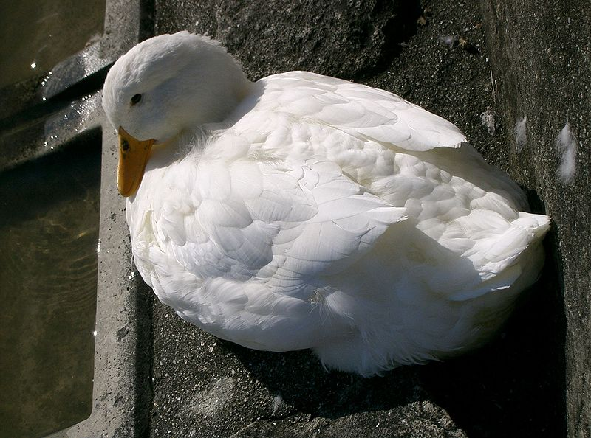
wool  meat (mutton, lamb)  cheese  milk | milk  cheese, butter  meat  wool (some breeds) | meat (duck)  eggs  feathers

Použité obrázky:

kuře | Thegreenj: Hen chicken.jpg. [cit. 2010-05-06]. Dostupné pod licencí GNU Free Documentation License na WWW: <http://commons.wikimedia.org/wiki/File:Hen_chicken.jpg>.
kráva | [cit. 2010-05-06]. Dostupné pod licencí Public Domain na WWW:  <http://www.pdclipart.org/displayimage.php?album=search&cat=0&pos=38>.
vepř | Joshua Lutz: Sus strofa strofa.jpg. [cit. 2010-05-06]. Dostupné pod licencí Public Domain na WWW: <http://commons.wikimedia.org/wiki/File:Sus_scrofa_scrofa.jpg>.
ovce | Jackhynes: Lleyn sheep.jpg. [cit. 2010-05-06]. Dostupné pod licencí Public Domain na WWW: <http://commons.wikimedia.org/wiki/File:Lleyn_sheep.jpg>.
koza | [cit. 2010-05-06]. Dostupné pod licencí Public Domain na WWW:  <http://www.pdclipart.org/displayimage.php?album=search&cat=0&pos=7>.
kachna | KENPEI: Domesticated duck1.jpg. [cit. 2010-05-06]. Dostupné pod licencí GNU Free Documentation License na WWW: <http://commons.wikimedia.org/wiki/File:Domesticated_duck1.jpg>.

