How many things are there?

Pupil 1

9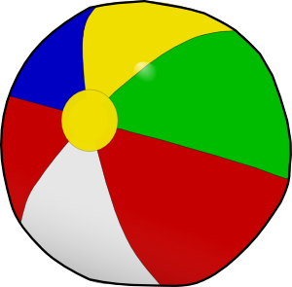 | 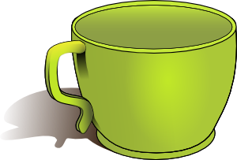 | 21 | 
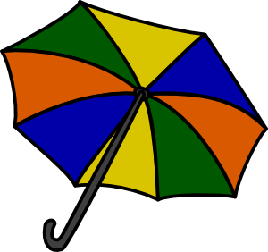 | 68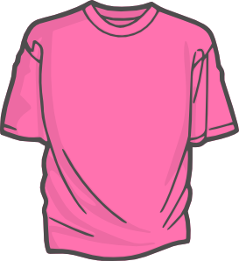 | 18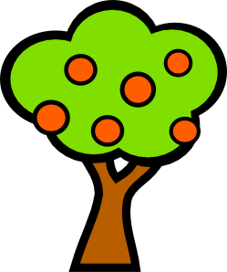 | 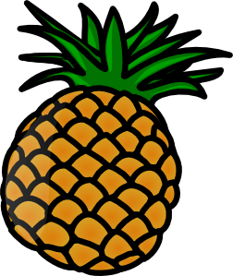
56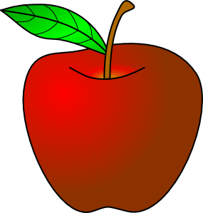 |  | 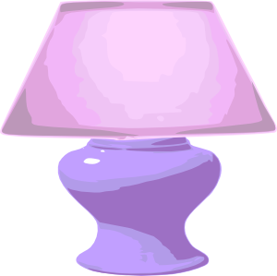 | 35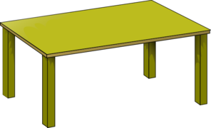
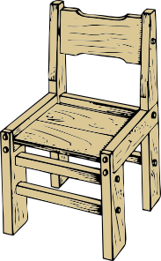 | 8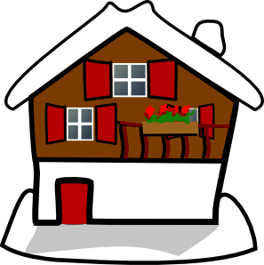 | 50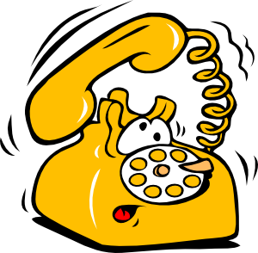 | 
47 | 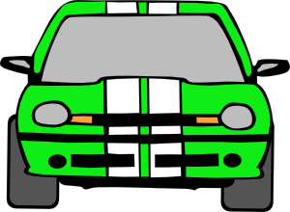 | 14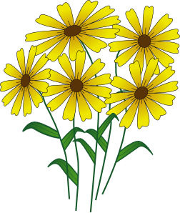 | 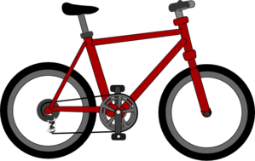

How many things are there?

Pupil 2
 | 15 |  | 29
62 |  |  | 31
 | 52 | 98
85 |  |  | 12
 | 33 |  | 22

Všechny uveřejněné odkazy [cit. 2012-03-10]. Dostupné pod licencí Public domain na WWW:

<http://www.clker.com/clipart-4597.html> míč
<http://www.clker.com/clipart-14579.html> hrníček
<http://www.clker.com/clipart-8564.html> kniha
<http://www.clker.com/clipart-15848.html> tužka
<http://www.clker.com/clipart-2935.html> deštník
<http://www.clker.com/clipart-15518.html> tričko
<http://www.clker.com/clipart-4004.html> strom
<http://www.clker.com/clipart-3998.html> ananas
<http://www.clker.com/clipart-3982.html> jablko
<http://www.clker.com/clipart-birthday-cake-four-candles.html> dort
<http://www.clker.com/clipart-11380.html> lampa
<http://www.clker.com/clipart-gold-table.html> stůl
<http://www.clker.com/clipart-10537.html> židle
<http://www.clker.com/clipart-3496.html> dům
<http://www.clker.com/clipart-4204.html> telefon
<http://www.clker.com/clipart-1981.html> pero
<http://www.clker.com/clipart-2963.html> klíč
<http://www.clker.com/clipart-3040.html> auto
<http://www.clker.com/clipart-2546.html> květina
<http://www.clker.com/clipart-spoilt-wheel-bike.html> kolo

