PODÍVEJ SE NA OBRÁZKY. POJMENUJ JE – ČINNOSTI. NASTŘÍHEJ OBRÁZKY.
PŘEČTI VĚTY, TAKÉ JE NASTŘÍHEJ. NALEP K SOBĚ PATŘÍCÍ VĚTY A OBRÁZKY.
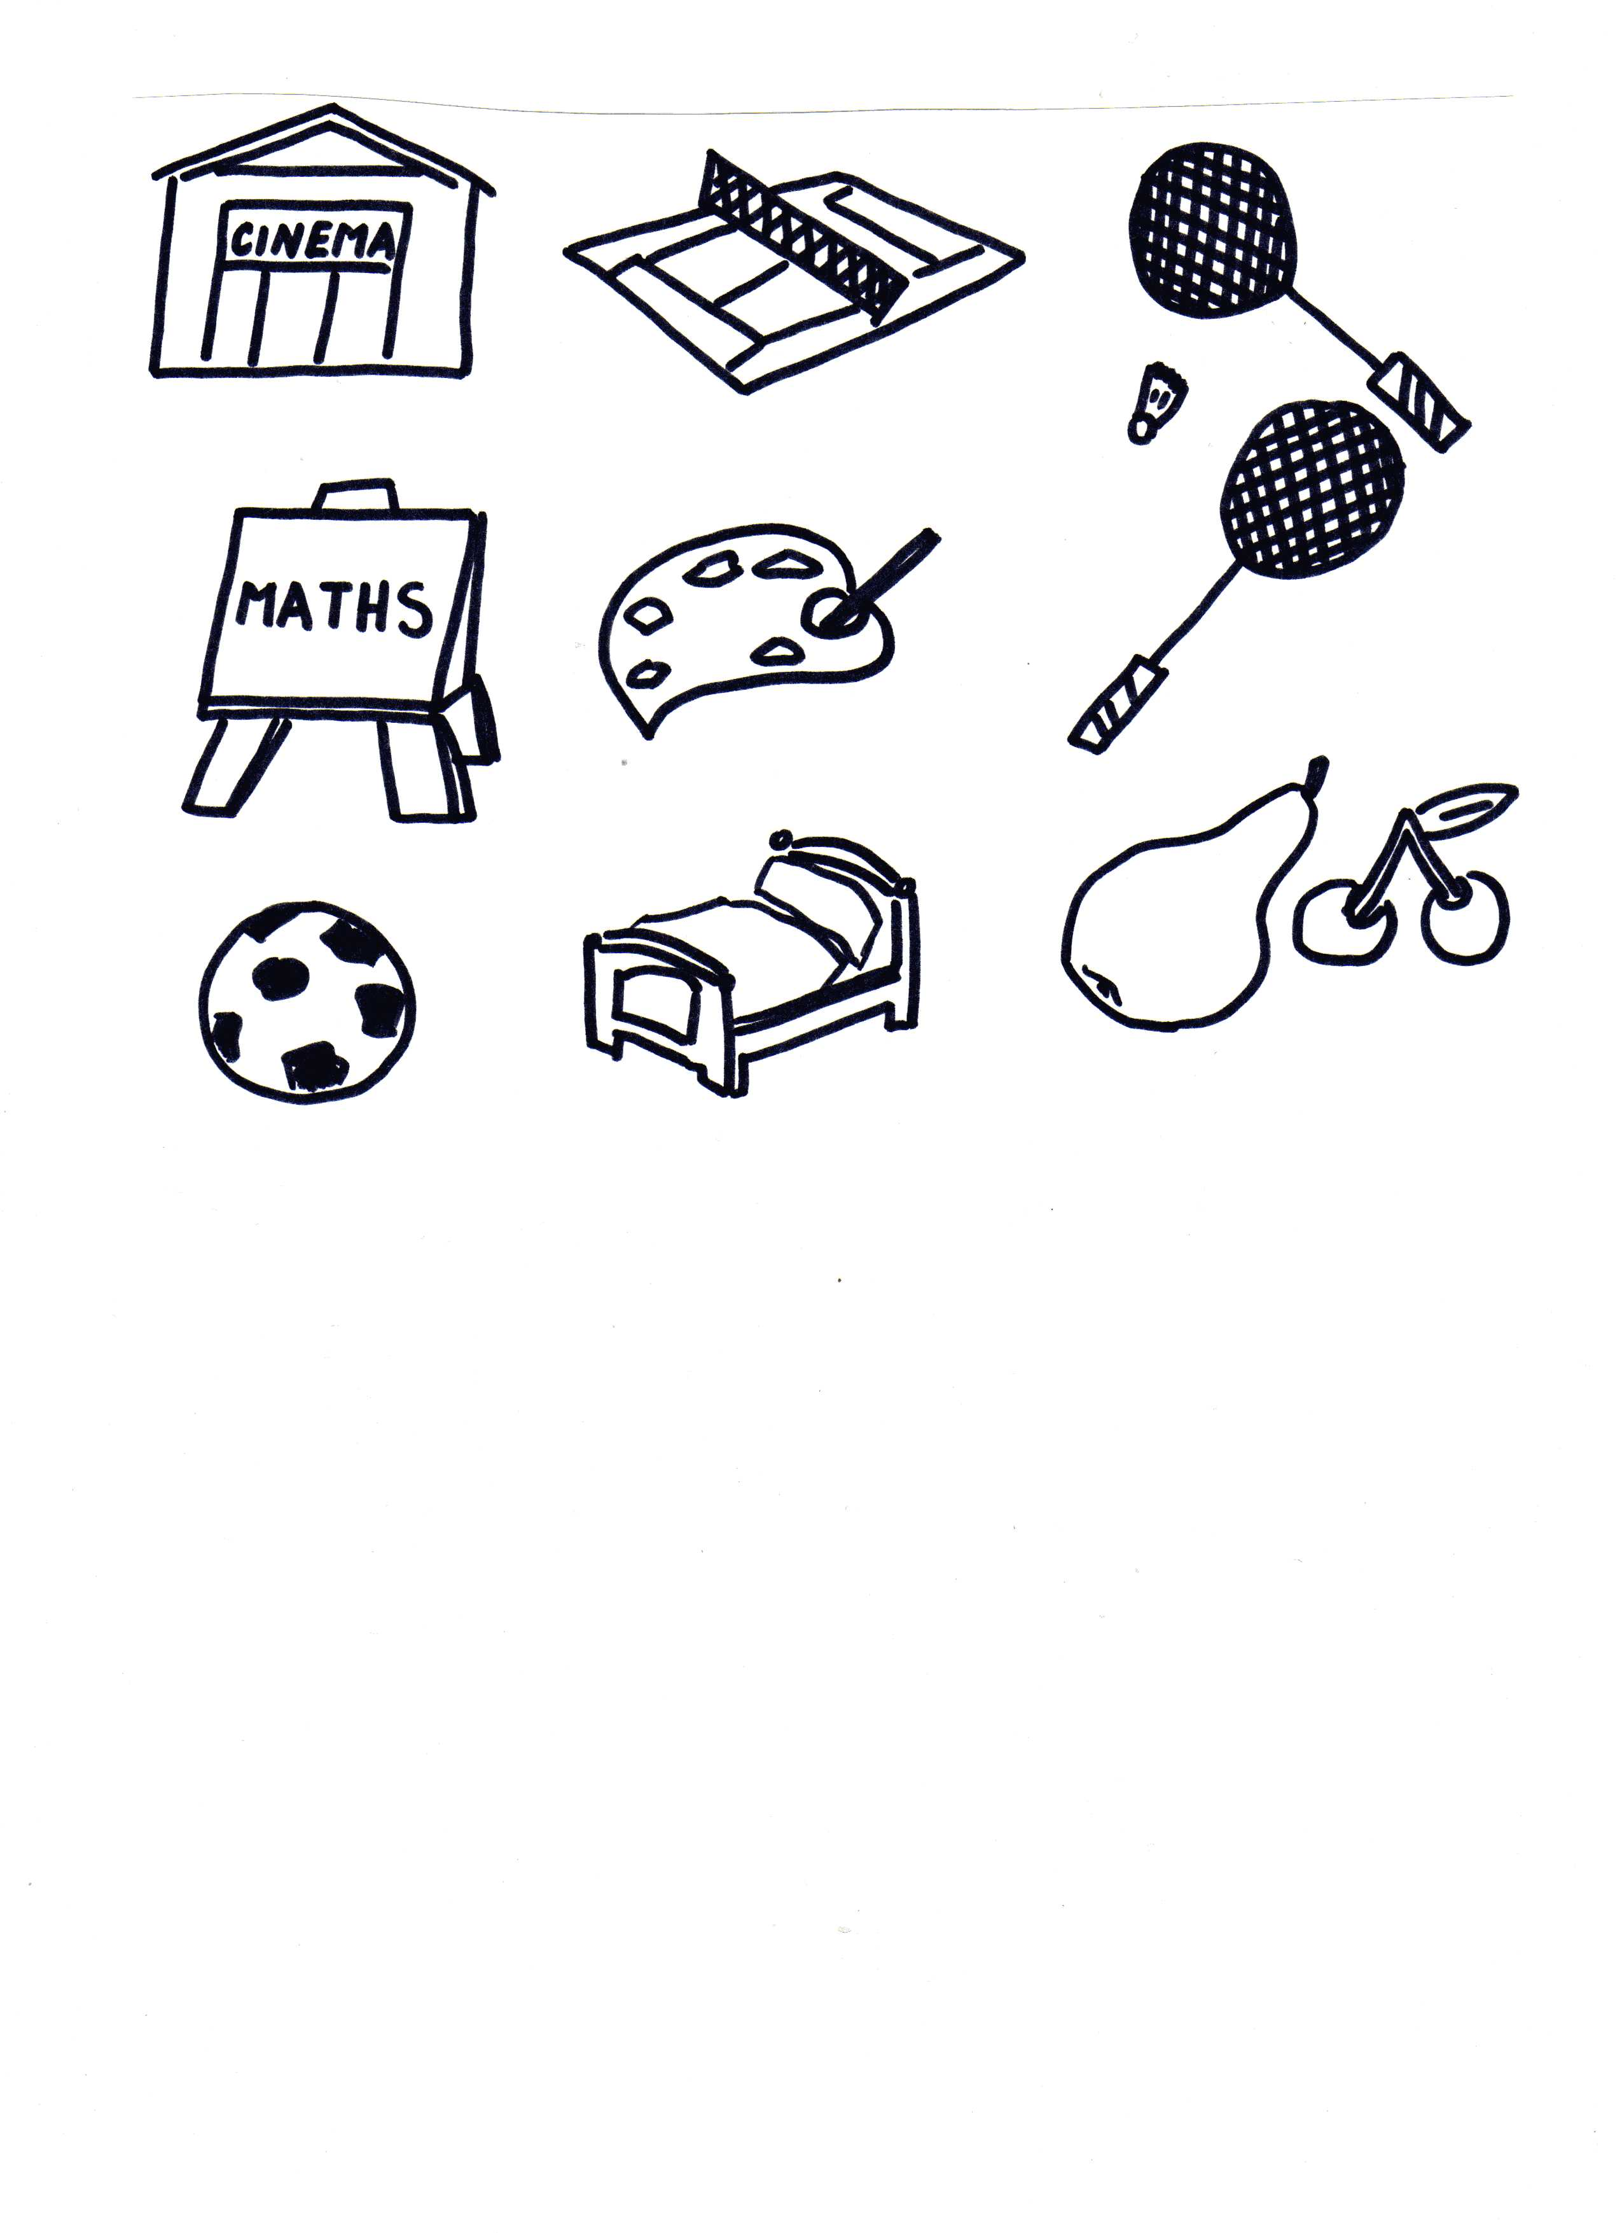
Autor © Dagmar Csatová

ALEX GOES TO THE CINEMA EVERY FRIDAY. | SONJA HAS A PEAR FOR SNACK. | I DON’T LIKE FILMS.
HELEN AND JAMES ARE PLAYING TENNIS AT THE MOMENT. | I LIKE EATING FRUIT. | WOULD YOU LIKE TO PLAY BADMINTON WITH ME?
ARE YOU GOING TO PLAY BADMINTON TONIGHT? | I OFTEN READ A BOOK IN MY BED. | WE USUALLY GO TO BED AT HALF PAST EIGHT PM.
PAUL PLAYS FOOTBALL VERY OFTEN. | WE HAVE SOME PEARS AND CHERRIES AT HOME. | PETER GOES TO THE CINEMA TWICE A MONTH.
TOM LIKES DRAWING WILD ANIMALS. | OUR MATHS LESSON STARTS AT EIGHT O’CLOCK. | WE LEARN MATHS THREE TIMES A WEEK.
DO THEY PLAY TENNIS ON MONDAY? | ALISON DOESN’T PLAY FOOTBALL. | JANE, WILL YOU DRAW AN ELEPHANT FOR ME, PLEASE?

