Pupil A

Look at the picture. What is there? Finish the sentences below.
Ask your partner about the differences in the pictures. Use Is there/are there…
Then answer your partner´s questions.





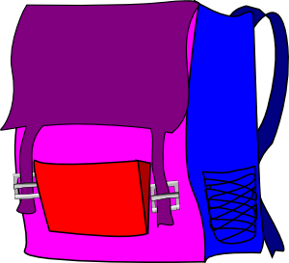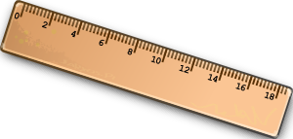

In the picture, there are three ________.

There are two ______.

There isn´t a ___________.

There aren´t any ____________.

There are four _____________.

There are also three _________.

There are _______ pens.

There are ______ rulers.

Zdroj obrázků:
Všechny uveřejněné odkazy [cit. 2010–11-07] dostupné pod licencí public domain – na www.clker.com

http://www.clker.com/clipart-2831.html
http://www.clker.com/clipart-1981.html
http://www.clker.com/clipart-2258.html
http://www.clker.com/clipart-3893.html
http://www.clker.com/clipart-14698.html
http://www.clker.com/clipart-ruler.html

