Pracovní list č. 1 Animals – vocabulary practice.
What is it? / Where does it live? / What does it look like? (Brainstorm your ideas.)
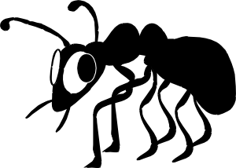 | 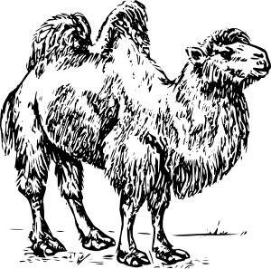 | 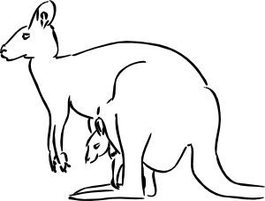 | 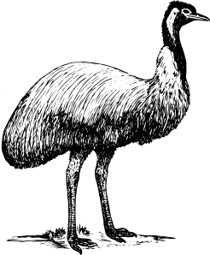
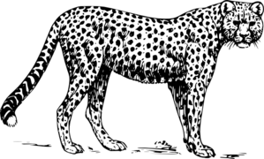 | 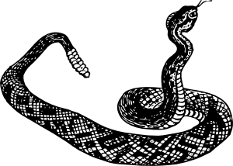 | 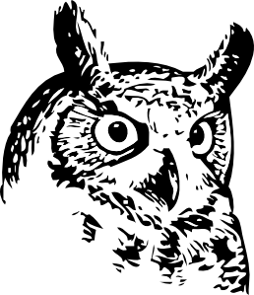 | 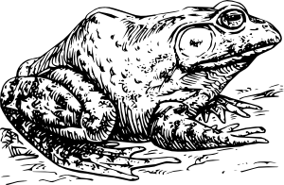
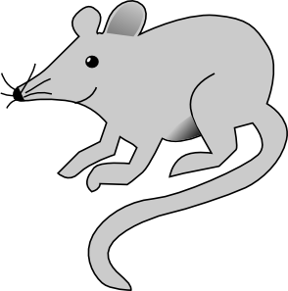 | 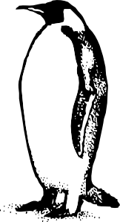 | 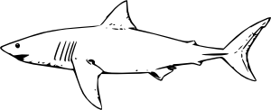 | 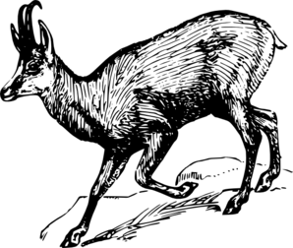
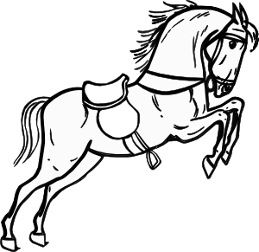 | 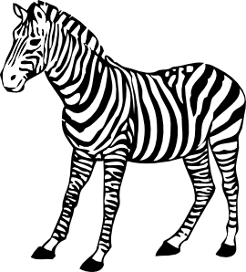 | 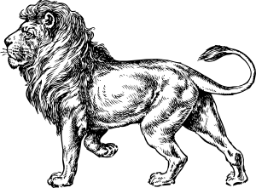 | 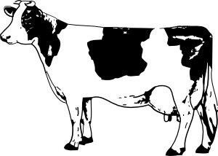
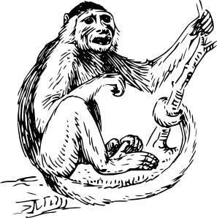 | 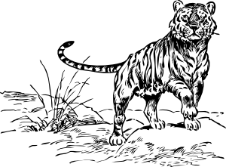 | 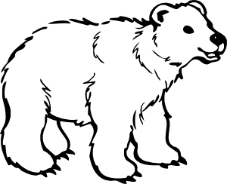 | 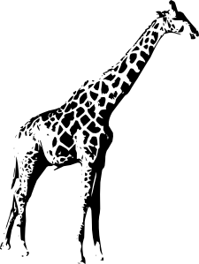

Pracovní list č. 2 Animals – fill in, read, cut and glue them to the pictures.
AN_ | NIGHT | O_ L | HEAVY | CO_
DESERT | SHA_ _ | JUMP | THE KING OF ANIMALS | FOUR LEGS
IT EAST MEAT. | FLY | AUSTRALIA | SHARP TEETH | RACE
SNA_ _ | MOUNTAIN  GO_ _ | DOMESTIC ANIMAL | MON_ _ _ | IT RUNS VERY FAST.
SHORT TAIL | OCEAN | VERY SMALL | BIG | A BIRD
HOR_ _ | HISS | TIG_ _ | GIRAF_ _ | CHEET_ H
PEN_U_N | CAM_ _ | CHEESE | FOREST | STRIPES
AFRICA | BANANAS | MOU_ _ | ZEB_ _ | GREEN
ZOO | MILK | BLACK AND WHITE | SHARP TEETH | FOUR LEGS
POLAR BE_ _ | MAMMAL | LI_ _ | BLACK AND WHITE | FARM
BROWN | DANGEROUS | KAN_ _ROO | IT DOESN´T SLEEP VERY MUCH | FRO_
WHITE | OSTR_ CH | POND | EATS MEAT | IT DOESN´T HAVE LEGS
LONG NECK | CRAWL | GREY | ASIA | ANTARCTICA

Pracovní list č. 3 Make sentences about these animals, use the words below.
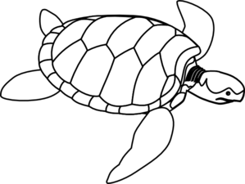
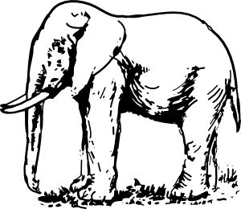
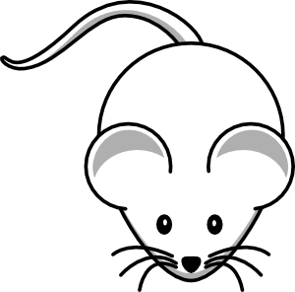

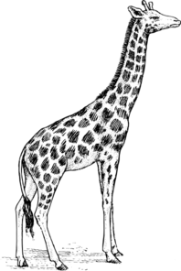
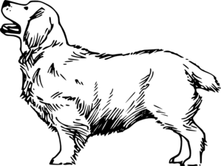
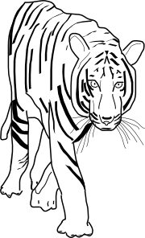

crocodiles / an elephant / a mouse / people / a tiger / a giraffe / a lion / a kangaroo
a turtle
lives / Asia / Australia / India / honey / Africa / savannah / farm / ZOO / trunk / neck animal/ ears
big ears / water / tree / ocean / dangerous / heavy / little / fast / jump / grass/ meat hunt
swim / bark / domestic / wild / slow / squeek / cheese / a mammal / spiders / brown grey / orange / trunks
--------------------------------------------------------------
Finish the following sentences with one word only.
Elephants live in …… Kangaroos have small …… A tiger is …… Elephants have long …… A giraffe has got a long …… Turtles usually live in the …… People are often afraid of …… A lion is …… Lions don´t eat …… Dogs live with …… Tigers often can climb the …… Crocodiles are very …… Elephants don´t have …… Camels live in …… Bees like …… Mice like … and they …… You can see …… in the ……
Pracovní list č. 4 Read, fill in the missing letters, build the correct words.
GIRAFFE | E_ _L_ | FSRONG
FROG | _IP_OP_T_MU_ | OSWTRIBCH
SNAKE | G_R_F_E | EWAGLEM
EAGLE | D_LP_I_ | KGOATS
INSECT | C_ _ | DBOLBPHIUN
DOLPHIN | _S_R_C_ | GTIRAFFEO
HIPPOPOTAMUS | _N_K_ | SNQAKEM
COW | _O_T | ACOWB
GOAT | F_O_ | INXSBECTB
OSTRICH | _N_E_T | HIPAPOPOYTAMUSA

Řešení vybraných úkolů
Pracovní list č. 2 Animals – fill in, read , cut and glue them to the pictures.
ANT | NIGHT | OW L | HEAVY | COW
DESERT | SHA_RK | JUMP | THE KING OF ANIMALS | FOUR LEGS
IT EAST MEAT. | FLY | AUSTRALIA | SHARP TEETH | RACE
SNAKE | MOUNTAIN  GOAT | DOMESTIC ANIMAL | MONKEY | IT RUNS VERY FAST.
SHORT TAIL | OCEAN | VERY SMALL | BIG | A BIRD
HORSE | HISS | TIGER | GIRAFFE | CHEETA H
PENGUIN | CAMEL | CHEESE | FOREST | STRIPES
AFRICA | BANANAS | MOUSE | ZEBRA | GREEN
ZOO | MILK | BLACK AND WHITE | SHARP TEETH | FOUR LEGS
POLAR BEAR | MAMMAL | LION | BLACK AND WHITE | FARM
BROWN | DANGEROUS | KANGAROO | IT DOESN´T SLEEP VERY MUCH | FROG
WHITE | OSTRI CH | POND | EATS MEAT | IT DOESN´T HAVE LEGS
LONG NECK | CRAWL | GREY | ASIA | ANTARCTICA

Pracovní list č. 3 Make sentences about these animals, use the words below.

crocodiles / an elephant / a mouse / people / a tiger / a giraffe / a lion / a kangaroo
a turtle
lives / Asia / Australia / India / honey / Africa / savannah / farm / ZOO / trunk / neck animal / ears
big ears / water /tree / ocean / dangerous / heavy / little / fast / jump / grass / meat hunt
swim / bark / domestic / wild / slow / squeek / cheese / a mammal / spiders / brown grey / orange / trunks
--------------------------------------------------------------
Finish the following sentences with one word only.
Elephants live in INDIA. Kangaroos have small EARS. A tiger is FAST. Elephants have long TRUNKS. A giraffe has got a long NECK. Turtles usually live in the WATER. People are often afraid of SPIDERS. A lion is very BROWN. Lions don’t eat GRASS. Dogs live with PEOPLE. Tigers often can climb the TREE. Crocodiles are very DANGEROUS. Elephants don’t have LONG TRUNKS. Camels live in FRICA. Bees like HONEY. Mice like CHEESE and they SQUEEK. You can see CROCODILES in the ZOO.

Pracovní list č. 4 Read, fill in the missing letters, build the correct words.
GIRAFFE | EAGLE | FSRONG  FROG
FROG | HIPPOPOTAUS | OSWTRIBCH  OSTRICH
SNAKE | GIRAFFE | EWAGLEM  EAGLE
EAGLE | DOLPHIN | KGOATS  GOAT
INSECT | COW | DBOLBPHIUN  DOPLHIN
DOLPHIN | OSTRICH | GTIRAFFEO  GIRAFFE
HIPPOPOTAMUS | SNAKE | SNQAKEM  SNAKE
COW | GOAT | ACOWB  COW
GOAT | FROG | INXSBECTB  INSECT
OSTRICH | INSECT | HIPAPOPOYTAMUSA  HIPPOPOTAMUS

Zdroj obrázků:
Všechny uveřejněné odkazy [cit. 2010-08-24]. Dostupné pod licencí Public Domain na WWW:
<http://www.clker.com/clipart-11112.html>
<http://www.clker.com/clipart-28921.html>
<http://www.clker.com/clipart-13632.html>
<http://www.clker.com/clipart-11773.html>
<http://www.clker.com/clipart-11230.html>
<http://www.clker.com/clipart-10417.html>
<http://www.clker.com/clipart-28910.html>
<http://www.clker.com/clipart-13915.html>
<http://www.clker.com/clipart-27018.html>
<http://www.clker.com/clipart-chamois.html>
<http://www.clker.com/clipart-11751.html>
<http://www.clker.com/clipart-jumping-horse-outline.html>
<http://www.clker.com/clipart-11673.html>
<http://www.clker.com/clipart-10436.html>
<http://www.clker.com/clipart-3354.html>
<http://www.clker.com/clipart-24846.html>
<http://www.clker.com/clipart-cheetah.html>
<http://www.clker.com/clipart-11756.html>
<http://www.clker.com/clipart-clumber.html>
<http://www.clker.com/clipart-6983.html>
<http://www.clker.com/clipart-simple-cartoon-mouse-1.html>
<http://www.clker.com/clipart-giraffe-2.html>
<http://www.clker.com/clipart-turtle-outline.html>
<http://www.clker.com/clipart-kangaroo.html>
<http://www.clker.com/clipart-11652.html>
<http://www.clker.com/clipart-11756.html>

