Pupil A: Read to your partner about what happened yesterday in your town.

Yesterday there was a robbery in a bank. Mr. James Wallis, the bank manager saw two people coming to the hall. He described both of them to the police officer:

I saw two people coming. They were a man and a woman. The woman was very young. I can’t remember her hair colour, but it was straight. Her mouth was small with a red lipstick on, her nose was small too. She was wearing a blue jacket and a black skirt. She was carrying a black leather handbag in her right hand, I think.
And the man…. Oh, he was quite young, too. He was wearing jeans and a long black coat. He pulled something out of his pocket. He had short straight hair, it was very dark. His nose was too long. That’s all I can remember.
The police office said: Thank you very much, I am sure we’ve got the people in the register.
Who robbed the bank?

Pupil’s B pictures:
Listen to the story and try to identify the robbers in the bank. Then finish the pictures according to the description.

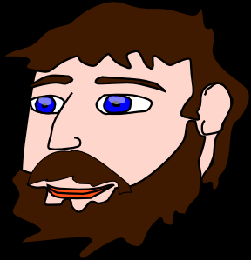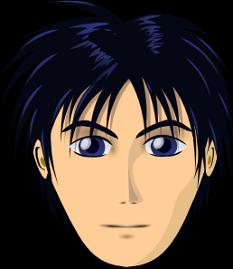

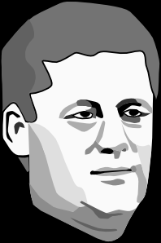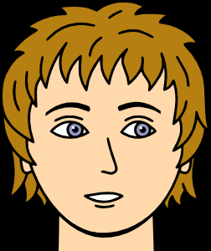

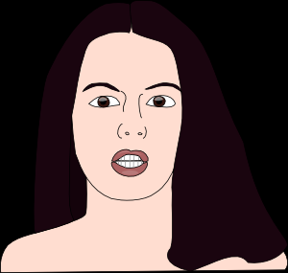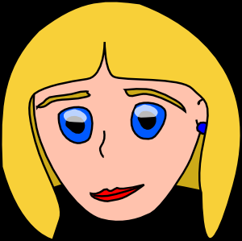

ŘEŠENÍ:

Zdroje obrázků:
Všechny uveřejněné odkazy [cit. 2010–13-02] dostupné pod licencí public domain – na http://www.clker.com.
http://www.clker.com/clipart-2324.html
http://www.clker.com/clipart-2313.html
http://www.clker.com/clipart-9354.html
http://www.clker.com/clipart-14259.html
http://www.clker.com/clipart-2314.html
http://www.clker.com/clipart-2319.html

