PUPIL A: LOOK AT THE BOXES WITH THE PICTURES.
PUPIL B: GET READY THE EMPTY BOXES.
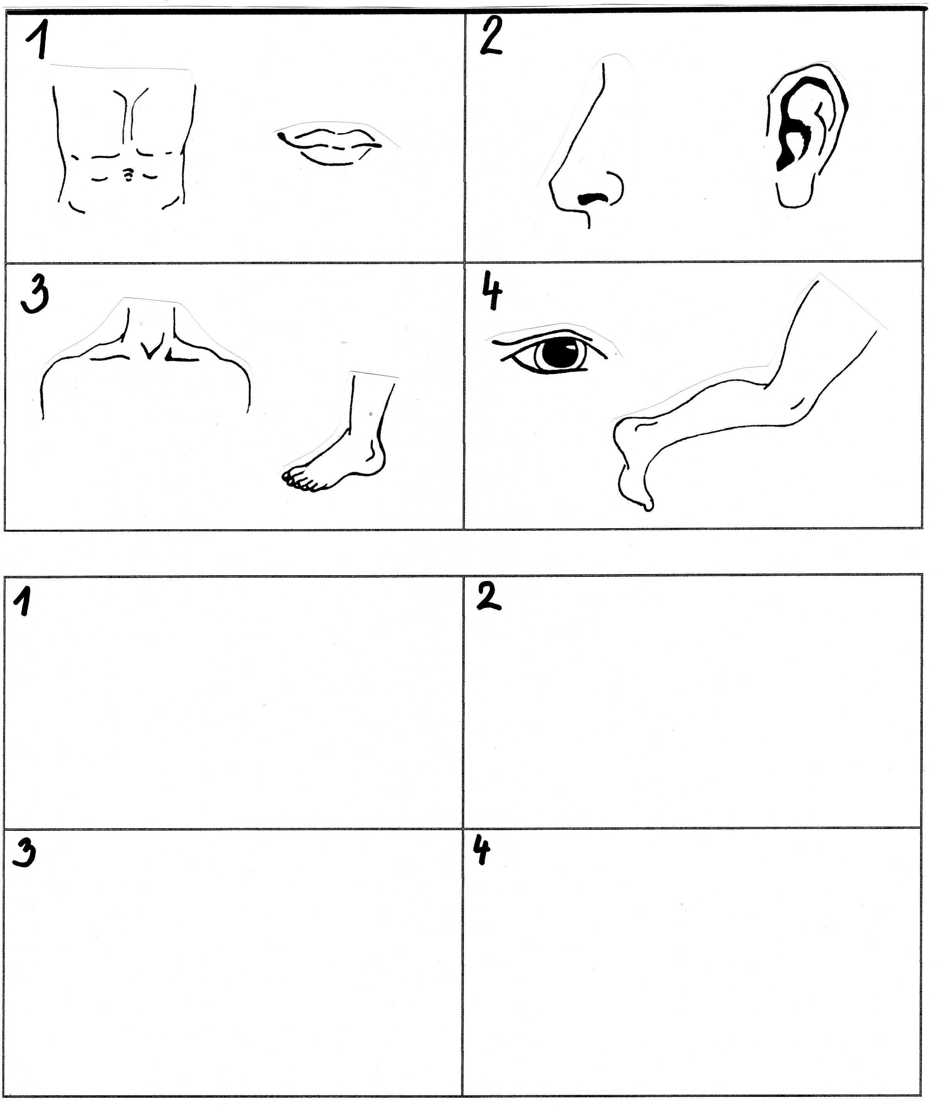
Autor © Dagmar Csatová
WORK IN PAIRS. DO NOT SHOW THE PICTURES TO YOUR PARTNER.

PUPIL A: DESCRIBE A PICTURE FOR YOUR PARTNER TO DRAW.
PUPIL B: LISTEN AND DRAW YOUR PARTNER´S PICTURES IN THE BOXES.

