LOOK AT THE MAP OF THE UNITED KINGDOM. CAN YOU PLACE THE INFORMATION FROM THE BOX IN THE CORRECT POSITION? YOU CAN USE THE BOOK OF MAPS IF YOU LIKE.

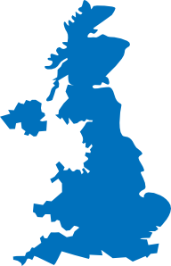

United Kingdom Map [cit. 2010-07-21]. Dostupný pod licencí Public domain na http://www.clker.com.
http://www.clker.com/clipart-24410.html

Climb the highest mountain in the United Kingdom
Take a ferry boat to France
The Sherwood forest (Robin Hood)
The biggest airport
The Shakespeare’s birthplace
It is the location of the Royal Observatory and a place where you can find the 0 meridian
The Beatles’ hometown
The battle took place here in 1066
Visit old colleges – Isaac Newton and Charles Darwin studied here.
Visit old colleges – the oldest university in United Kingdom

Řešení :

Climb the highest mountain in the United Kingdom | Ben Nevis
Take a ferry boat to France | Dover
The Sherwood forest (Robin Hood) | Nottingham
The biggest airport (Heathrow) | London
The Shakespeare’s birthplace | Stratford upon Avon
It is the location of the Royal Observatory and a place where you can find the 0 meridian | London-Greenwich
The Beatles’ hometown | Liverpool
The battle took place here in 1066 | Hastings
Visit old colleges – Isaac Newton and Charles Darwin studied here. | Cambridge
Visit old colleges – the oldest university in UK | Oxford

